Introduction
„Automobile“ or „car“ is something we are wery used to! Almost everyone is travelling at least once every week by car. Products are delivered to our local store by cargo car or „truck“ as we know it. Public transportation relies mostly on big special cars for transporting many people – buses.
What do we know about them?
Before the automobile, people both lived in the city and worked in the city, or lived in the country and worked on a farm. Because of the automobile, the growth of suburbs has allowed people to live on the outskirts of the city and be able to work in the city by commuting. New jobs due to the impact of the automobile such as fast food, city/highway construction, state patrol/police, convenience stores, gas stations, auto repair shops, auto shops, etc. allow more employment for the world's growing population. (The Center for LifeLong Learning and Design)

Cars in Estonia
There are relatively few cars in Estonia and cars are relatively old! In the following table You see total number and percentage of different age groups of cars, trucks and buses in Estonia in 2012.

Automobile
By definition an automobile, autocar, motor car or car is a wheeled vehicle that carries its own motor and transports passengers. (Bellis)
Most definitions of the term specify that automobiles are designed to run primarily on roads, to have seating for one to eight people, to typically have four wheels, and to be constructed principally for the transport of people rather than goods. (Wikipedia, 2012)
The term motorcar has also been used in the context of electrified rail systems to denote a car which functions as a small locomotive but also provides space for passengers and baggage. These locomotive cars were often used on suburban routes by both interurban and intercity railroad systems
It was estimated in 2010 that the number of automobiles had risen to over 1 billion vehicles, with 500 million reached in 1986. The numbers are increasing rapidly, especially in China and India. (Wikipedia, 2012)

Etymology
The word automobile comes, via the French automobile from the Ancient Greek word αὐτός (autós, "self") and the Latin mobilis ("movable"); meaning a vehicle that moves itself. The alternative name car is believed to originate from the Latin word carrus or carrum ("wheeled vehicle"), or the Middle English word carre ("cart") (from Old North French), in turn these are said to have originated from the Gaulish word karros (a Gallic Chariot). (Wikipedia, 2012)

History
The first working steam-powered vehicle was designed - and possibly built - by Ferdinand Verbiest, a Flemish member of a Jesuit mission in China around 1672. It was a 65 cm-long scale-model toy for the Chinese Emperor, that was unable to carry a driver or a passenger. It is not known if Verbiest's model was ever built.
Nicolas-Joseph Cugnot is widely credited with building the first full-scale, self-propelled mechanical vehicle or automobile in about 1769; he created a steam-powered tricycle (Illustration 1). He also constructed two steam tractors for the French Army, one of which is preserved in the French National Conservatory of Arts and Crafts. His inventions were however handicapped by problems with water supply and maintaining steam pressure.
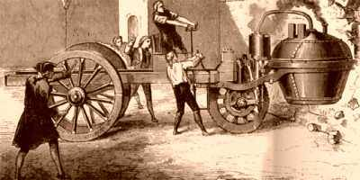
Illustration 1 Cugnot’s steam tricycle (Bellis)
In 1807 Nicéphore Niépce and his brother Claude probably created the world's first internal combustion engine which they called a Pyréolophore, but they chose to install it in a boat on the river Saone in France. Coincidentally, in 1807 the Swiss inventor François Isaac de Rivaz designed his own 'de Rivaz internal combustion engine' and used it to develop the world's first vehicle to be powered by such an engine.
In November 1881, French inventor Gustave Trouvé demonstrated a working three-wheeled automobile powered by electricity at the International Exposition of Electricity, Paris.
Although several other German engineers (including Gottlieb Daimler, Wilhelm Maybach, and Siegfried Marcus) were working on the problem at about the same time, Karl Benz (Illustration 2) generally is acknowledged as the inventor of the modern automobile.
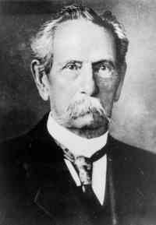
Illustration 2 Karl Benz, the inventor of the modern automobile (Wikipedia, 2012)
In 1879, Benz was granted a patent for his first engine, which had been designed in 1878. Many of his other inventions made the use of the internal combustion engine feasible for powering a vehicle. His first Motorwagen (Illustration 3) was built in 1885 in Mannheim, Germany. He was awarded the patent for its invention as of his application on 29 January 1886 (under the auspices of his major company, Benz & Cie., which was founded in 1883). Benz began promotion of the vehicle on 3 July 1886, and about 25 Benz vehicles were sold between 1888 and 1893, when his first four-wheeler was introduced along with a model intended for affordability. In August 1888 Bertha Benz, the wife of Karl Benz, undertook the first road trip by car, to prove the road-worthiness of her husband's invention.
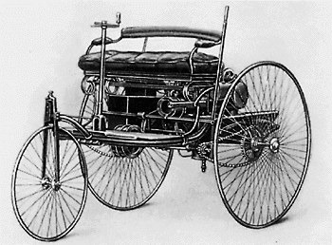
Illustration 3 original Benz Patent-Motorwagen, first built in 1885 (Wikipedia, 2012)
In 1896, Benz designed and patented the first internal-combustion flat engine, called boxermotor. During the last years of the nineteenth century, Benz was the largest automobile company in the world with 572 units produced in 1899 and, because of its size, Benz & Cie., became a joint-stock company.
The first motor car in central Europe and one of the first factory-made cars in the world, was produced by Czech company Nesselsdorfer Wagenbau (later renamed to Tatra) in 1897, the Präsident automobil.
In 1890, Émile Levassor and Armand Peugeot of France began producing vehicles with Daimler engines, and so laid the foundation of the automobile industry in France.
The first design for an American automobile with a gasoline internal combustion engine was made in 1877 by George Selden of Rochester, New York. Selden applied for a patent for an automobile in 1879, but the patent application expired because the vehicle was never built.
In Britain, there had been several attempts to build steam cars with varying degrees of success, with Thomas Rickett even attempting a production run in 1860. Santler from Malvern is recognized by the Veteran Car Club of Great Britain as having made the first petrol-powered car in the country in 1894 followed by Frederick William Lanchester in 1895, but these were both one-offs. The first production vehicles in Great Britain came from the Daimler Motor Company, a company founded by Harry J. Lawson in 1896, after purchasing the right to use the name of the engines. Lawson's company made its first automobiles in 1897, and they bore the name Daimler.
In 1892, German engineer Rudolf Diesel was granted a patent for a "New Rational Combustion Engine". In 1897, he built the first Diesel Engine. Steam-, electric-, and gasoline-powered vehicles competed for decades, with gasoline internal combustion engines achieving dominance in the 1910s.
Although various pistonless rotary engine designs have attempted to compete with the conventional piston and crankshaft design, only Mazda's version of the Wankel engine has had more than very limited success.

Seating and body style
Most cars are designed to carry multiple occupants, often with four or five seats. Larger cars can often carry six, seven or more occupants depending in the internal arrange of seats. Sports cars are often designed with only two seats, and very occasionally three seats. The differing needs for passenger capacity and their luggage has resulted in a large variety of body styles to suit personal requirements such as the sedan/saloon, hatchback, station wagon/estate and Multi-Purpose Vehicle/Minivan. (Wikipedia, 2012)
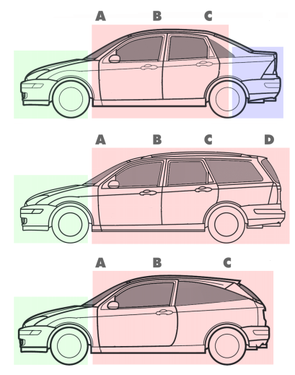
Illustration 4 Typical pillar configurations of a sedan (three box), station wagon (two box) and hatchback (two box) from the same model range. (Wikipedia, 2012)

Sedan
A sedan (American English, Canadian English, Australian English; play /sɨˈdæn/) or saloon car (British English, Irish English, New Zealand English) is a passenger car in a three-box configuration with A, B & C-pillars and principal volumes articulated in separate compartments for engine, passenger and cargo.[1] The passenger compartment features two rows of seats and adequate passenger space in the rear compartment for adult passengers. The cargo compartment is typically in the rear, with the exception of some rear-engined models, such as the Renault Dauphine, Tatra T613, Volkswagen Type 3 and Chevrolet Corvair. It is one of the most common car body styles. (Wikipedia, 2012)
The word sedan is possibly derived from a southern Italian dialect derivative of Italian sedia "chair" (the first sedan was said to have been introduced from Naples). However, Portuguese and Spanish navigators and colonists encountered litters of various sorts in India, Japan, Mexico, and Peru. They were imported into Spain in the late sixteenth century. Soon the fashion spread into France and then England. All the names for these derived from the root "sed-" from the Latin "sella" - the traditional name for a carried chair. (Wikipedia, 2012)

Types of sedans
Several versions of the body style exist, including four-door, two-door, nine-door and fastback variants of both.
A sedan seats four or more people and has a fixed roof that is full-height up to the rear window. The roof structure will typically have a fixed B-pillar on sedan models. Most commonly it is a four-door; two-door models are rare, but they do occur (more so historically). In the U.S., the term sedan has been used to denote a car with fixed window frames, as opposed to the hardtop style without a "B" pillar and where the sash, if any, winds down with the glass. However, true hardtops have become increasingly rare.
Four-door sedans can have either two or three side windows: One in each door (vent windows not counted), and the possible third integrated in the "C"-pillar. (Wikipedia, 2012)

Notchback sedans
A notchback sedan (Illustration 5) is a three-box sedan, where the passenger volume is clearly distinct from the trunk volume of the vehicle (when seen from the side). The roof is on one plane, generally parallel to the ground, the rear window at a sharp angle to the roof, and the trunk lid is also parallel to the ground. (Wikipedia, 2012)
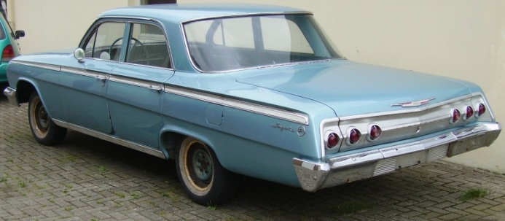
Illustration 5 1962 Chevrolet Impala, a typical notchback sedan (Wikipedia, 2012)

Fastback sedans
A fastback sedan (Illustration 6) is a two-box sedan, with continuous slope from the roof to the base of the decklid, but excludes the hatchback feature. Marketing terminology is often misleading in this area - for example, Daimler AG calls the Mercedes-Benz CLS-Class sedan a four-door coupé because its semi-fastback design tries to give the impression of a coupé. Certain sedans are edging close to being one-box vehicles, where the windshield is steeply raked from the hood/bonnet and the rear window slopes toward almost the end of the car, leaving just a short rear deck that is part of the trunk lid - the 2006 4-door JDM Honda Civic is an example of this. They are not fastbacks because their bodyline changes from the roof to the rear deck. Their steeply raked rear windows end with a decklid that does not continue down to the bumper. Instead, their rear ends are tall - sometimes in a Kammback style - to increase trunk space.
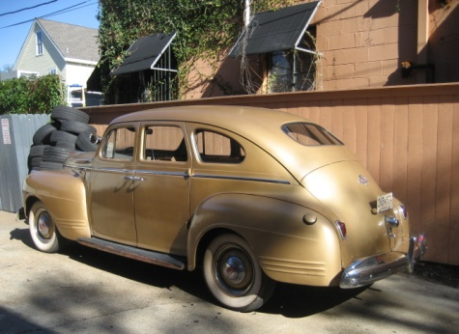
Illustration 6 1941 Plymouth fastback sedan (Wikipedia, 2012)
Typically this design is chosen for its aerodynamic advantages. Automakers can no longer afford the penalty in fuel consumption produced by the traditional notchback three box form. (Wikipedia, 2012)

Hardtop sedans
In historic terminology a sedan will have a frame around the door windows, while the hardtop has frameless door glass. A true hardtop sedan (Illustration 7) design also has no "B" pillar (the roof support behind the front doors). This body style has an open feel, but requires extra underbody strengthening for structural rigidity. The hardtop design can be considered separately (i.e., a vehicle can be simply called a four-door hardtop), or it can be called a hardtop sedan. During the 1960s and 1970s, hardtop sedans were often sold as sport sedans by American manufacturers and were among the top selling body styles. During the 1980s, automakers in the U.S. focused on removing weight and increasing strength, and their new four-door sedans with B-pillars were called pillared hardtops or pillared sedans. The sport sedan term has since been appropriated for other uses. In Japan, and among Japanese manufacturers worldwide, the hardtop design was popular among luxury sedans throughout the 1990s. (Wikipedia, 2012)
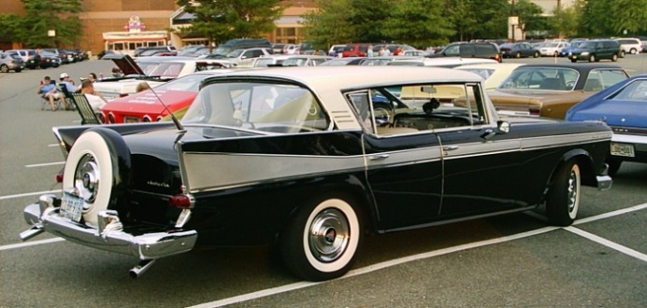
Illustration 7 1958 AMC Ambassador hardtop sedan (Wikipedia, 2012)

Hatchback sedans
Hatchback (a.k.a. liftback) sedans (Illustration 8) typically have the fastback profile, but instead of a trunk lid, the entire back of the vehicle lifts up (using a liftgate or hatch). A vehicle with four passenger doors and a liftgate at the rear can be called a four-door hatchback, four-door hatchback sedan, or five-door sedan. An example of such is the Chevrolet Malibu Maxx and Audi A5 Sportback. There can also be two-door hatchback sedans (three-door sedans), by the same technical explanation for two-door sedans. Examples of this design are the Volkswagen Golf, and Chevrolet Chevette. (Wikipedia, 2012)
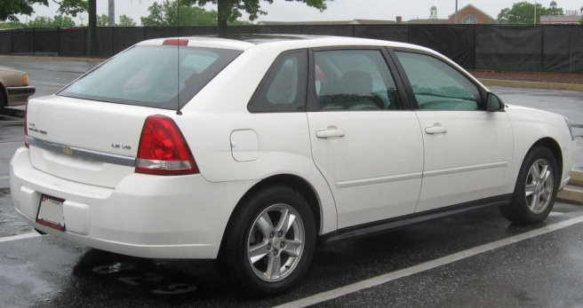
Illustration 8 Chevy Malibu Maxx hatchback sedan (Wikipedia, 2012)

Chauffeured sedans
Strictly speaking limousine sedans (Illustration 9) have a separate compartment for the driver and the passenger compartment is long enough to contain at least two comfortable, forward-facing bench seats. Vehicles used for these means are usually Lincoln Town Car, Cadillac, Mercedes, or Rolls-Royce or Maybach for the more wealthy. The term limousine can refer to a large sedan, especially if hired from a service. Chauffeured limousines are primarily used by individuals for weddings, businesses for meetings, as well as for airport and sightseeing transportation. Chauffeurs are professional drivers, usually with experience in the transportation industry or tourism industry. Chauffeured sedans are owned either by private owners, livery services, or corporations. Large corporations as well as governments commonly provide luxury sedans to top executives, as well as VIP guests. Chauffeured sedans, such as the Lincoln Town Car, may also be stretched into limousines that are capable of seating up to twenty people. (Wikipedia, 2012)
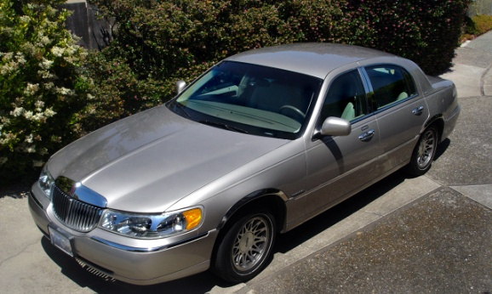
Illustration 9 The Lincoln Town Car is often used as a chauffeured car in the U.S. (Wikipedia, 2012)

Station Wagon
A station wagon (Illustration 10) (also known as an estate or estate car) is an automobile with a body style variant of a sedan/saloon with its roof extended rearward over a shared passenger/cargo volume with access at the back via a third or fifth door (the liftgate or tailgate), instead of a trunk lid. The body style transforms a standard three-box design into a two-box design—to include an A, B, and C-pillar, as well as a D-pillar. Station wagons can flexibly reconfigure their interior volume via fold-down rear seats to prioritize either passenger or cargo volume.
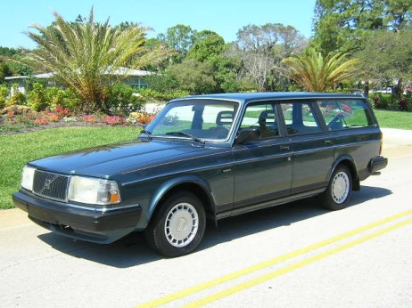
Illustration 10 Volvo Station Wagon (Wikipedia, 2012)
The American Heritage Dictionary defines a station wagon as "an automobile with one or more rows of folding or removable seats behind the driver and no luggage compartment but an area behind the seats into which suitcases, parcels, etc., can be loaded through a tailgate."
When a model range includes multiple body styles, such as sedan, hatchback and station wagon, the models typically share their platform, drivetrain and bodywork forward of the A-pillar. In 1969, Popular Mechanics said, "Station wagon-style ... follows that of the production sedan of which it is the counterpart. Most are on the same wheelbase, offer the same transmission and engine options, and the same comfort and convenience options."
Station wagons have evolved from their early use as specialized vehicles to carry people and luggage to and from a train station, and have been marketed worldwide. (Wikipedia, 2012)

Minivan
Minivan (Illustration 11) is a type of van designed for personal use. Minivans are typically either two-box or one box designs for maximum interior volume – and are taller than a sedan, hatchback, or a station wagon.
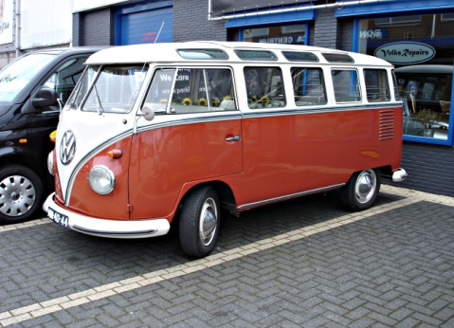
Illustration 11 Volkswagen Type 2(Wikipedia, 2012)
Worldwide, minivans are also marketed as multi-purpose vehicles (MPVs), multi-utility vehicles (MUVs), people-carriers or people-movers. (Wikipedia, 2012)

Car classification
Cars may be classified by a number of different criteria and objectives. However, comprehensive classification is elusive, because a vehicle may fit into multiple categories, or not completely satisfy the requirements for any. This article details the commonly used classifications and definitions. (Wikipedia, 2012)
- Microcar
- Hatchbacks
  - Ultracompact car
  - City car
  - Supermini/subcompact car
  - Small family car/compact car
  - Hot hatch
- Saloons / sedans
  - Large family / mid-size
  - Compact executive
  - Full size / large
  - Executive/mid-luxury
  - Full-size luxury / Grand saloon
- Estate cars / station wagons
- Sports cars and grand tourers
  - Sports saloon / sports sedan
  - Sports car
  - Grand tourer
  - Supercar
  - Muscle car
  - Pony car
- Convertible
- Off-roaders
  - Sport utility vehicle
  - Crossover SUV
- Multi-purpose vehicles/Minivans
- Van, camper, RV, minibus etc. (Wikipedia, 2012)

Other car classification terms
- Bakkie
- Buggy
- Cabrio coach or Semi-convertible
- Corniche
- El Camino
- Estate car
- Fastback
- Drop Head Coupe
- Flower Car
- Kammback
- Landaulet
- Liftback
- Limousine
- Microvan
- Notchback
- Phaeton
- Ragtop
- Sedan delivery
- Spyder (or Spider)
- Shooting-brake
- Targa top
- Town car (US)
- Ute
- Wagon delivery (Wikipedia, 2012)

Non-English terms
Some non-English language terms are familiar from their use on imported vehicles in English-speaking nations even though the terms have not been adopted into English.
- Barchetta
- Berlina
- Berline
- Berlinetta
- Break
- Camioneta
- Carrinha
- Espada
- Furgoneta
- Furgão
- Kombi
- Perua
- Turismo (Wikipedia, 2012)

Conclusion
This is a breaf overview of cars. We didn’t cover trucks, buses. Didn’t talk about Fire Trucks or Ambulance vans. So everyone can see, this topic is almost endless.
Hopefully every car fan found something useful here.

