Dance
First of all – dance is something You do on parties, when You have good time with people You like. So dance is a ritual of good emotions, good feelings, it’s something You do to express Your attitude. Almost everyone has danced sometimes.
Dance is something You can do without special training all You need is Your feet, music and few squarefeet of space. Dance is somethig You can train, You can dance professionally. So Dance can be pure fun, it can be fun job.
This reserch paper gives a short overview of dance, the definition, the origin, some history, some classification. As this Year 2014 is another Song and Dance Celebration in Estonia, this paper has emphasis on Estonian folk dance and dance celebration.
Why Estonian folk dance? Estonians consider themselves as people of song and dance. Estonians have really long history of dancing. Estonian men are often called „lions of dance“. Practically every party in Estonia involves some dancing, sometimes through the night until dancers are death tired. Estonians and dance – these two go together.
Dance is a type of art that generally involves movement of the body, often rhythmic and to music. It is performed in many cultures as a form of emotional expression, social interaction, or exercise, in a spiritual or performance setting, and is sometimes used to express ideas or tell a story. Dance may also be regarded as a form of nonverbal communication between humans or other animals, as in bee dances and behaviour patterns such as a mating dances.
Definitions of what constitutes dance can depend on social and cultural norms and aesthetic, artistic and moral sensibilities. Definitions may range from functional movement (such as folk dance) to virtuoso techniques such as ballet. Martial arts kata are often compared to dances, and sports such as gymnastics, figure skating and synchronized swimming are generally thought to incorporate dance.
There are many styles and genres of dance. African dance is interpretative. Ballet, ballroom and tango are classical dance styles. Square dance and electric slide are forms of step dance, and breakdancing is a type of street dance. Dance can be participatory, social, or performed for an audience. It can also be ceremonial, competitive or erotic. Dance movements may be without significance in themselves, as in ballet or European folk dance, or have a gestural vocabulary or symbolic meaning as in some Asian dances.
Choreography is the art of creating dances. The person who creates (i.e., choreographs) a dance is known as the choreographer.
(Wikipedia, 2014)
There are many good choreographers in Estonia who create lot of folk style dances every year!

Dance in Estonia
Estonia has a long history of dance.

Folk dance in Estonia
Throughout history dance has given various nations an opportunity to record their experiences, feelings and personalities. Not all nations have been able to create strong dancing traditions, but the most famous dances become known abroad. Thus, in the 14th and 15th centuries in the courts of Europe, people danced the Italian tarantella and French minuets and quadrilles. In the 16th and 17th centuries, English square and sword dances were popular. The following century gave us the waltz and lendler of German-Austrian origin. The list is endless. But what about Estonians? How do they fit into this cultural picture?
The experience of the previous century shows that an average Estonian is not too fond of dancing. In the future the situation might change in the face of the co-occurrence of favourable conditions (the warming of the climate, assimilation of nations, changing of patterns of thought), but so far the consumer of Estonian culture has preferred musical events to dance shows. We can speculate that this kind of attitude has grown out of the previous centuries. Hard work in the field or on the sea and very little sunshine, which was necessary for work, did not leave much time for dancing. Singing was another matter as it could be done even while working. Parties were held. Young people always loved to get together on Saturday evenings to enjoy singing and music. Usually they gathered at someone’s house, where there was homemade beer. There they sat and drank, did round dances and jigged to the music.
A more defined period in the history of folk dance began in the middle of the 19th century, when the establishment of native language high culture was considered very important as a guarantee of national awakening and ethnic survival. Estonian associations, which were founded all over the country, played an important role; choirs and orchestras were established in parishes. In the euphoria of choirs and song festivals, folk dance was left in the shadows. It seems unbelievable, but only a century ago it was thought that Estonians had no national dance. People only knew and remembered Kaera-Jaan, which was danced as a folk dance. The origin of Kaera-Jaan is very interesting in itself, even though it has also caused heated arguments.
According to Friedebert Tuglas’s notes it is a mocking song from 1889. At that time in Ahja manor there lived a cottager, Piitre Matson, who was called the Oat Emperor. He got his sobriquet from the fact that he only sowed oats around his cottage. The affix ‘Kaera' (Oat) was also added to the names of his many children. Piitre’s son Jaan Matson was a blacksmith’s apprentice at Ahja manor and a great ladies’ man. This mocking song was created about him:
"Ai Kaara-Jaan, ai Kaara-Jaan, / ai karga vällä kaema, / kas on kesvä keerulise, / kaara kateharulise." Kaera-Jaan was considered to be an Estonian national dance by foreign students from as far away as the Caucasus, who encountered the dance in Tartu. For fun it was even given a fancier name: Jean de Kaër. It is thought that this dance became so popular due to the fact that from the beginning it was tied to a specific tune and movements.
At some point the collectors of folklore also started to collect and describe folk dances. The main instigator was the Estonian Students’ Association, under the management of Oskar Kallas (1868–1946). The search for pure Estonian folk dance, which had begun in 1930, ended with the realisation that such a thing did not exist. It became apparent that our folk dances are at times very similar to the dances of other nations. For example it was found that our very popular labajalavalss (an Estonian folk waltz) is just an ordinary folkloric waltz; kaerajaan was linked with the quadrille, and tuljak, a dance-tale of the courting of two young people, to Slavonic dances.
Carried by the attitudes of the time people started discussing the possibilities for developing folk art. It was suggested that folk dance should be approached creatively, adjusting it according to the spirit of the time. Change has actually always been one of the characteristics of folk dance — like human creation in general, folk dance changes according to the times and people, reflecting important events. This is the reason why we today cannot distinguish between original and later dances. Film and other authentic recording means are too new, and thus it is not possible to refer to documented sources and say which part or figure in a dance is older and which newer.
So what are the characteristics of Estonian folk dance? Estonian folk dance is considered to be collective, peaceful and dignified. There are no big leaps or fast and varied movements, and acrobatic elements are uncommon. Estonian folk dance is best characterised as a series of repeated motifs and simple patterns of movement. Repetitive motifs are actually characteristic of all Estonian folk art — they can be found in folk poems, ornamentation on belts, woodwork and other things.
It is thought that our oldest dances were those for men, with a simple pattern and accompanying music. Mainly they consist of mimicking dances, mostly line or group dances, in which a set number of dancers take part. In the old days, dance meant walking in a circle in one of the biggest cottages and singing, for example, Vares vaga linnukene and other round dance songs. Estonian applause is generally internal and feelings are seldom expressed through extra movements.
A teacher of Estonian folk dance, Ullo Toomi [Illustration 6] (1902–1983) writes: '... When in the music or movement there is a rise, turn or stressed movement of feet, then for a second the dancer’s reserve disappears and we can see what is hidden deep within. The turns and movements of feet are quick and forceful, the posture and expression change, and then it seems as if their patience has run out and only now will the real dance begin...But no, the mind again reins in the feelings and surmised temperament. Only a small stretch follows, and the head is tossed back with an air of superiority. And then the former self-conscious mute peace returns once more.'
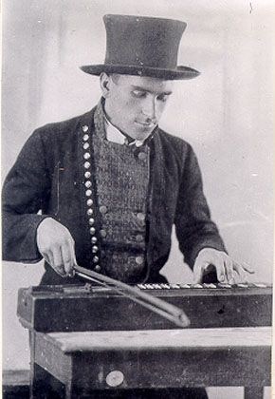
Illustration 6 Dance teacher Ullo Toomi, 1927 (Ehrenbusch, 2012)
However, there could also be another reason for the slow nature of Estonian folk dances. The ethnographical folk dances were mostly written down according to the directions and demonstrations of old people, who, due to their advanced age, danced with difficulty and were more heavy-footed. Naturally they were not able to accomplish light leaps or take fast steps. Some eyewitnesses’ accounts and the names of older dances such as 'Tuuletants' ('The wind dance'), 'Kuradipolka' ('Devil’s polka'), and 'Marukibe' ('Very bitter') tell of very different tempos and characteristics of dances.
Our folk dance is indeed characterised by its peaceful nature, but in comparison with other nations there is a large variety of basic steps against a background of unity of style. Considering country waltzes, in different places so many steps or tricks have been added or eliminated to a particular dance that even within one parish people could not dance it in the same way. In every region a dance was adjusted to match the people, environment and experienced events.
In the repertoire of today’s folk dance groups not much remains of the original authentic ethnographic creation. Dances are characterised by mixed styles. In 1926 Anna Raudkats (1886–1965) published a book, Estonian folk dance, the aim of which was to introduce Estonian dance and to revive old folk dances in parties and gatherings. The popularity of folk dance grew, but people did not start dancing these dances for their own enjoyment (with the exception of the jooksupolka — running polka), but only as performance dances. However, we have Raudkats to thank for the fact that we have dances in a national style and of performance quality that are created on the basis of old sources and yet appear contemporary.
In 1976 Mait Agu (1951–1998) established in Tallinn Pedagogical Institute a faculty for teaching professional dance instructors/pedagogues who could teach folk dance, teach new dancers and generally contribute to the development of Estonian dance. Agu was a talented dance teacher who managed dance festivals and arranged stage choreographies in various genres. He was one of our most famous modernisers of folk dance, and his work is characterised by choreographies containing elements of folk dance, character dance and ballet, which were arranged on the basis of pop songs and performed in national costumes. Those dances do not have much of the original folk movements or depth, but the public liked the temperamental performances and tunes familiar from the radio.
Folk dance as such has nowadays become almost a sport, in which all the participants must move very elaborately and in the same way. As a result, the natural swaying and irregularity, which at social gatherings create that cosy feeling of unity, disappears. This was the reason why, at the end of the 20th century, dance clubs were formed — these were an alternative to folk dance groups where people mostly prepared for dance festivals. The aim of these dance clubs is to learn old dance patterns, to change and vary them, each club in its own way, in order to promote the tradition of social dance throughout the nation. In these dance clubs old traditional dances are learned without the necessity of 'pointing one’s toes', peacefully and following one’s instincts. Actually it is the realisation of the idea Anna Raudkats offered almost a hundred years ago — to bring the dance back to the people.
(Ehrenbusch, 2012)

Beginning of modern dance and ballet in Estonia
Estonian artistic dance, i.e. the dance of theatre stages or concert halls, did not grow out of the traditions of folk dance, but rather is the product of contemporary choreographers intended as an expression of high culture. Artistic dance only originated at the beginning of the 20th century, when Estonian drama became professional and found better opportunities for development in new, big theatre buildings: 'Vanemuise', built in 1906 in Tartu, and the 'Estonia' theatre, built in Tallinn in 1913, and later the smaller theatres of the city. The development of artistic dance was originally influenced by Isadora Duncan’s 'free dance' and Russian classical ballet.
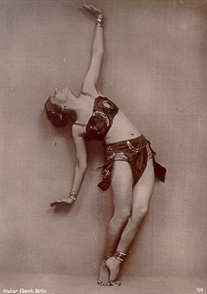
Illustration 7 Elmerice Parts in Berlin in the 1930s (Ehrenbusch, The beginning of modern dance and classical ballet, 2012)
Just before World War I, Elmerice Parts (1888–1974) [Illustration 7] opened, in Tartu, a studio for aesthetic gymnastics, which was based on Duncan’s technique. The first performance of the young girls of the studio and their teacher was a remarkable event of freshness, uniqueness and beauty — the girls were all dressed in white Greek tunics bound with golden ribbon which was tied around the waist and crossed on the chest. Similar golden ribbons were in their hair, and they were barefoot or wore golden sandals, moving freely and gracefully, running, jumping, arching like bows, by ones or twos or in colourful groups. It was a huge success. Unfortunately Elmerice Parts could not work in Estonia for very long because of the war. Thus this first initiative in dance pedagogy did not leave a noticeable mark on the later development of Estonian dance culture, but it did provide impetus for the formation of Estonian expressive and artistic dance.
In characterising the dance style of those days, it could be said that an effort was made to give expression to the lyrical core of creation in a gentle, delicately cultivated, gracefully expressive outline. However, a more extravagant subject matter was strived for. Erotic dances were danced and machine-like movements mimicked, yielding to a lust-filled daze as well as merciless rhythm..
Soon a new dance school was founded in Tallinn, more oriented towards a normative technique appropriate for theatre stages and group dances and the traditions of classical ballet than towards individual creation. In 1913 a soloist of the former Petersburg 'Maria Theatre', Eugenie Litvinova, came to live in Tallinn. Five years later, she established there a studio of classical ballet. It can be said that most of the famous Estonian ballet artists of that time have come from her school. Litvinova’s school can be characterised as possessing impeccable precision and meticulous attention to stylistic purity. For a long time the theatre seasons of Tallinn were enriched with dance shows only by the students of Litvinova’s school. The programme usually contained a short pantomime or a fragment of a longer expressive performance.
The further development of modern dance in Central Europe caused great interest in Estonia. A Hungarian with an education in classical ballet, Rudolf von Laban, was at that time working very actively in Germany, trying to establish modern dance on similar basic motifs as classical ballet had acquired over the centuries. Modern dance had to be led out of the limitedness and uniqueness of individual geniality and given a specific technical basis, with a system of certain basic movements, tensions and trends. In order to acquire the new approach, appropriate practice regimens had to be created, with corresponding techniques and methodologies. Laban accomplished all that.
A student of Laban, Gerd Neggo, founded his own studio in Tallinn in 1924; his teaching was based on Laban’s methods. Every year he consistently organised performances for his studio, the programmes consisting of both solo and group dances and also of some pantomimes. Later Gerd Neggo and his group performed in the Estonian Drama Theatre, especially in plays for children and young people, where an occasional dance element was needed. In this way, Laban’s school’s modern aspirations of dance were directly applied to Estonian stage performance.
Of the older Estonian theatres, dance was mostly cultivated in the 'Estonia Theatre' in Tallinn. At first the theatre had to make do with random dancers and ballet masters who did not stay for long. A student of Litvinova, Rahel Olbrei (1896–1984), began working in 1920 in the 'Estonia Theatre' as a dancer. Later she became a ballet master full of energy and ideas. In 1926 Olbrei put together a permanent ballet troupe, consisting mainly of young people with no education in the field of dance. She herself gave them dance lessons. With the foundation of a troupe that was stylistically consistent and first-rate, she aimed for mastery and a combination of different dance styles. In her dance performances she stressed dramaturgic progress and intrinsic expressiveness.
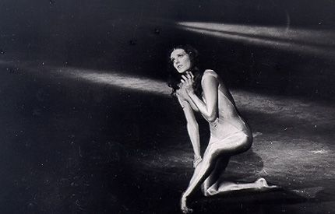
Illustration 8 Kaie Kõrb (Ehrenbusch, The beginning of modern dance and classical ballet, 2012)
During the Soviet period and under pressure from authorities, many ethnographic works were created in ballet. The topics varied from folk tales to stylised and rearranged folk dances. Naturally there also appeared much choreography that portrayed/characterised Soviet life and its people. The ballets created by the old masters did not disappear, but the Soviet censors made sure that the repertoire did not contain anything 'demoralising'.
The face of Estonian ballet has been shaped most by Mai-Ester Murdmaa’s (1938) creation, which has been widely recognised also outside Estonia. Murdmaa's style can be characterised as a search for new ways of choreographic expression and a desire to open the depths of the human soul through plastic images. In her choreography she has strived for a philosophical interpretation of the world. Her choice of repertoire as head ballet master has been extremely wide and has given proof of her intelligence and open mind. Her productions have mostly played to full houses and they have always been met with a variety of reactions. It can certainly be said that her work is not meant for the masses, but for people who like to think and search. Murdmaa has worked very closely with the most famous ballet dancer of Estonia, Kaie Kõrb (1961) [Illustration 8], for whom she has also created individual roles.
(Ehrenbusch, The beginning of modern dance and classical ballet, 2012)

Origins of dance
Dance does not leave behind clearly identifiable physical artifacts such as stone tools, hunting implements or cave paintings. It is not possible to say when dance became part of human culture, but archeological evidence indicates dance has been an important part of ceremony, rituals, celebrations and entertainment since the earliest human civilizations. Examples of such evidence include 9,000 year old paintings in India at the Rock Shelters of Bhimbetka, and Egyptian tomb paintings depicting dancing figures, dated c. 3300 BC.
One of the earliest structured uses of dances may have been the telling of myths. Before the invention of written languages, dance was one of the methods of passing stories down from generation to generation. Dance was also used to show feelings for one of the opposite gender. It is also linked to the origin of "love making." Another early use of dance may have been as a precursor to ecstatic trance states in healing rituals. Dance is still used for this purpose by many cultures from the Brazilian rainforest to the Kalahari Desert.
Many contemporary dance forms can be traced back to historical, traditional, ceremonial, and ethnic dance. For example, some Sri Lankan dances are related to aboriginal, mythical devils known as "yakkas", and according to local legend, Kandyan dance began as a ritual that broke the magic spell on a bewitched king.
Many early forms of music and dance were created for each other and performed together. This paired development has continued over time, producing paired dance/music forms such as the jig, waltz, tango, disco, and salsa. Some musical genres have a parallel dance form such as baroque music and baroque dance; others, such as classical music and classical ballet, developed separately.
Although dance is often accompanied by music, it can also be performed without music, or it may provide its own audible accompaniment as in tap dance. When performed with music, dance may or may not be performed in time to the music (synchronous to the music's time signature).
(Wikipedia, 2014)

Classification of dance
Dance can be categorized in various ways, such as by the number of interacting dancers, as in solo dance, partner dance and group dance [Illustration 1], or by purpose, as in ceremonial dance, erotic dance, performance dance, and social dance.
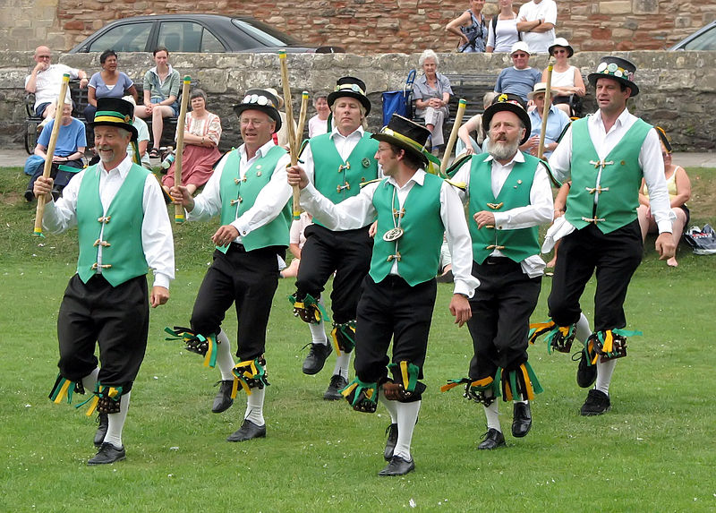
Illustration 1 Group dance (Wikipedia, 2014)
Dance genres are often categorized by ethnicity or geographic region.
(Wikipedia, 2014)

Dance education, occupation and object of competition
Today, dance can be Your occupation and You can study dancing in universities.

Dance Education
Dance education emerged as an academic discipline in the early 1920s, and by the late 20th century, recognition of the academic value of practical knowledge led to the acceptance of practice research in academic dance education programs. Today dance studies are offered through the arts and humanities programs of many higher education institutions, leading to Bachelor of Arts and higher academic degrees. A dance study curriculum may encompass a diverse range of courses and topics, including dance practice and performance, choreography, ethnochoreology, dance notation, and dance therapy.
(Wikipedia, 2014)

Dance as occupation
Today, You can have occupation related to dance.

Dancer
Professional dancers [Illustration 2] are usually employed on contract or for particular performances or productions. The professional life of a dancer is generally one of constantly changing work situations, strong competitive pressure and low pay.
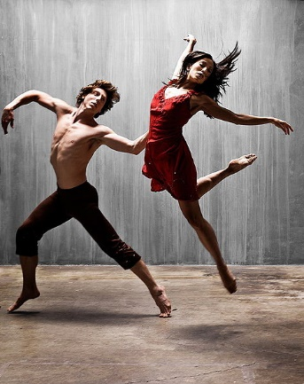
Illustration 2 Professional dancers (Wikipedia, 2014)
Consequently, professional dancers often must supplement their incomes to achieve financial stability. In the U.S. many professional dancers belong to unions (such as the American Guild of Musical Artists, Screen Actors Guild and Actors' Equity Association) that establish working conditions and minimum salaries for their members.
(Wikipedia, 2014)

Dance Teacher
Dance teachers typically focus on teaching dance performance, or coaching competitive dancers, or both. They typically have performance experience in the types of dance they teach or coach. For example, dancesport teachers and coaches are often tournament dancers or former dancesport performers.
Dance teachers may be self-employed, or employed by dance schools or general education institutions with dance programs. Some work for university programs or other schools that are associated with professional classical dance (e.g., ballet) or modern dance companies. Others are employed by smaller, privately owned dance schools that offer dance training and performance coaching for various types of dance.
(Wikipedia, 2014)

Choreographer
In dance, choreography is the act of designing dance. Choreography may also refer to the design itself, which is sometimes expressed by means of dance notation. A choreographer is one who designs dances. Dance choreography is sometimes called dance composition.
Aspects of dance choreography include the compositional use of organic unity, rhythmic or non-rhythmic articulation, theme and variation, and repetition. The choreograhic process may employ improvisation for the purpose of developing innovative movement ideas. In general, choreography is used to design dances that are intended to be performed as concert dance.
The art of choreography involves the specification of human movement and form in terms of space, shape, time and energy, typically within an emotional or non-literal context. Movement language is taken from the dance techniques of ballet, contemporary dance, jazz dance, hip hop dance, folk dance, techno, k pop, religious dance, pedestrian movement, or combinations of these.
(Wikipedia, 2014)
Choreographers are often university trained and are typically employed for particular projects or, more rarely may work on contract as the resident choreographer for a specific dance company.
(Wikipedia, 2014)

Dance competitions
A dance competition is an organized event in which contestants perform dances before a judge or judges for awards, and in some cases, monetary prizes. There are several major types of dance competitions, distinguished primarily by the style or styles of dances performed. Major types of dance competitions include:
- Competitive dance, in which a variety of theater dance styles, such as acro, ballet, jazz, hip-hop, lyrical, and tap, are permitted.
- Open competitions, that permit a wide variety of dance styles. A popular example of this is the TV program So You Think You Can Dance.
- Dancesport, which is focused exclusively on ballroom and latin dance. Popular examples of this are TV programs Dancing with the Stars and Strictly Come Dancing.
- Single-style competitions, such as; highland dance, dance team, and Irish dance, that only permit a single dance style.
Today, there are various dances and dance show competitions on television and the Internet.
(Wikipedia, 2014)

Concert dance
Concert dance (also known as performance dance or theatre dance in the United Kingdom) is dance performed for an audience. It is frequently performed in a theatre setting, though this is not a requirement, and it is usually choreographed and performed to set music.
By contrast, social dance and participation dance may be performed without an audience and, typically, these dance forms are neither choreographed nor danced to set music, though there are exceptions. For example, some ceremonial dances and baroque dances blend concert dance with participation dance by having participants assume the role of performer or audience at different moments.

Concert dance forms
Many dance styles are principally performed in a concert dance context, including these:
- Ballet [Illustration 3] originated as courtroom dance in Italy, then flourished in France and Russia before spreading across Europe and abroad. Over time, it became an academic discipline taught in schools and institutions. Amateur and professional troupes formed, bringing ballet from the courts to the theater and making it one of the most widely performed concert dance styles today.
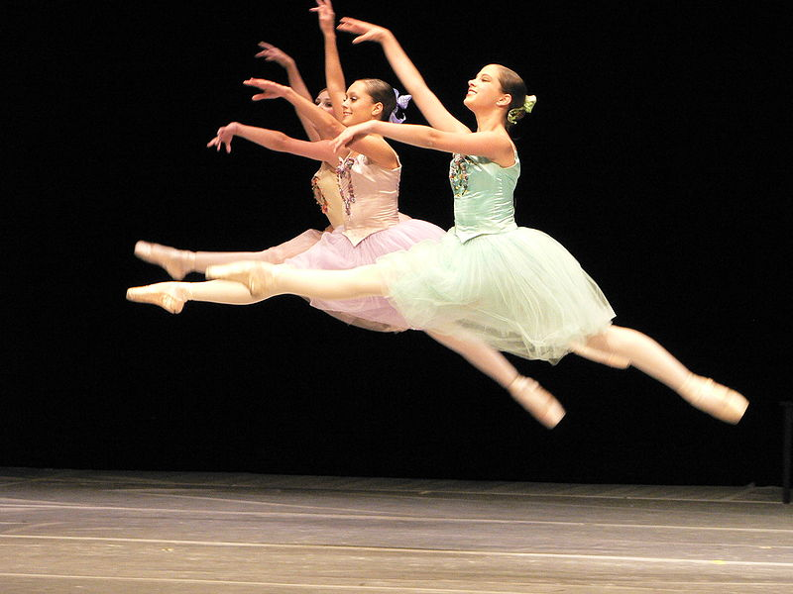
Illustration 3 Ballet dancers executing grand jetes (Wikipedia, 2014)
- Acrobatic dance emerged in the United States and Canada in the early 1900s as one of the types of acts performed in vaudeville. Acro dance has evolved significantly since then, with dance movements now founded in ballet technique. From its inception, acro dance has been a concert dance form.
- Classical Indian dance originated in temples in India. After the Indian independence movement (1947 to 1950), dance became a university subject, dance schools appeared for the first time, and classical Indian dance became a concert dance form performed in theaters.
- Classical Persian dance was elevated to an art form during the Qajar dynasty (1795 to 1925). It was performed in the royal court of the Shah and it remained there and among the elite and bourgeois families until the 20th century. Since then, it has evolved into its modern-day form and become a widely performed concert dance style.
Others
- Belly dance
- Bharatanatyam
- Contemporary dance
- Eurythmy
- Hip hop dance
- Jazz dance
- Modern dance
- Tap dance
(Wikipedia, 2014)
Nowadays even folk dance can be a concert dance and performed on large stage.

Ballroom dance
Ballroom dance is a set of partner dances, which are enjoyed both socially and competitively [Illustration 4] around the world, and growing all the more popular in North America. Because of its performance and entertainment aspects, ballroom dance is also widely enjoyed on stage, film, and television.
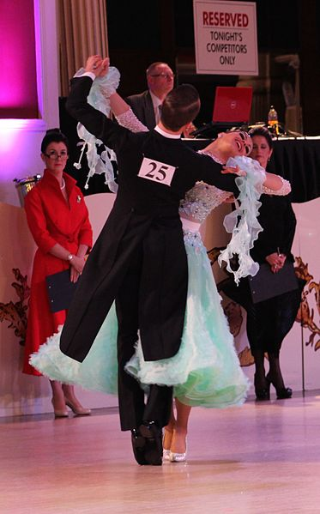
Illustration 4 Competition of ballroom dances (Wikipedia, 2014)
Ballroom dance may refer, at its widest definition, to almost any type of partner dancing as recreation. However, with the emergence of dancesport in modern times, the term has become narrower in scope. Traditionally, the term refers to the five International Standard and five International Latin style dances (see dance categories below). The two styles, while differing in technique, rhythm and costumes, exemplify core elements of ballroom dancing such as control and cohesiveness. Developed in England, the two styles are now regulated by the World Dance Council (WDC). In the United States, two additional variations are popular: American Smooth and American Rhythm, which combine elements of both traditional Latin and Ballroom dances.
There are also a number of historical dances, and local or national dances, which may be danced in ballrooms or salons. Sequence dancing, in pairs or other formations, is still a popular style of ballroom dance.
The term 'ballroom dancing' is derived from the word ball, which in turn originates from the Latin word ballare which means 'to dance' (a ball-room being a large room specially designed for such dances). In times past, ballroom dancing was social dancing for the privileged, leaving folk dancing for the lower classes. These boundaries have since become blurred, and it should be noted even in times long gone, many ballroom dances were really elevated folk dances. The definition of ballroom dance also depends on the era: balls have featured popular dances of the day such as the Minuet, Quadrille, Polonaise, Polka, Mazurka, and others, which are now considered to be historical dances.
(Wikipedia, 2014)

Folk dance
Folk dances [Illustration 5] are dances that share some or all of the following attributes:
- Dances performed at social functions by people with little or no professional training, often to traditionally based music.
- Dances not generally designed for public performance or the stage, though they may later be arranged and set for stage performances.
- Execution dominated by an inherited tradition rather than innovation (though folk traditions change over time)
- New dancers often learn informally by observing others and/or receiving help from others.
More controversially, some people define folk dancing as dancing for which there is no governing body or dancing for which there are no competitive or professional institutions. The term "folk dance" is sometimes applied to dances of historical importance in European culture and history; typically originating before the 20th century. For other cultures the terms "ethnic dance" or "traditional dance" are sometimes used, although the latter terms may encompass ceremonial dances.
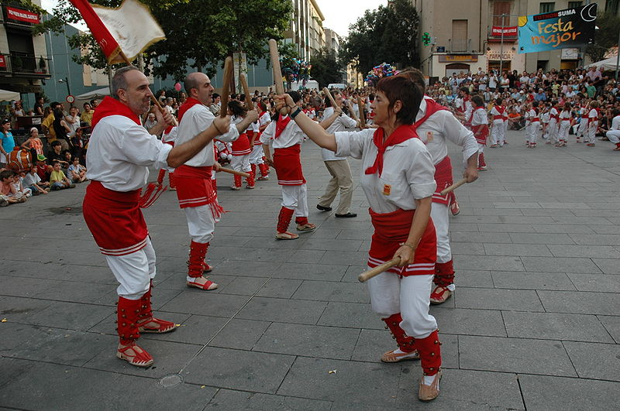
Illustration 5 Folk dancers in Catalonia (Wikipedia, 2014)
There are a number of modern dances, such as hip hop dance, that evolve spontaneously, but the term "folk dance" is generally not applied to them, and the terms "street dance" or "vernacular dance" are used instead. The term "folk dance" is reserved for dances which are to a significant degree bound by tradition and originated in the times when the distinction existed between the dances of "common folk" and the dances of the "high society".
A number of modern ballroom dances originated from folk ones.
The terms "ethnic" and "traditional" are used when it is required to emphasize the cultural roots of the dance. In this sense, nearly all folk dances are ethnic ones. If some dances, such as polka, cross ethnic boundaries and even cross the boundary between "folk" and "ballroom dance", ethnic differences are often considerable enough to mention, e.g., Czech polka vs. German polka.
Not all ethnic dances are folk dances; for example, ritual dances or dances of ritual origin are not considered to be folk dances. Ritual dances are usually called "Religious dances" because of their purpose.
(Wikipedia, 2014)

European folk dances
Varieties of European folk dances include:
- Ball de bastons
- Barn dance
- Céilidh
- Clogging
- English country dance
- Georgian folk dances
- Greek dances
- Hora
- International folk dance
- Maypole dance
- Morris dance
- Welsh Morris dance
- Polka
- Polonez
- Turkish dance
- Verbuňk
- Nordic polska dance
- Square dance
- Sword dance
- Kolo
Sword dances include Longsword dances and rapper dancing. Some choreographed dances such as contra dance, Scottish country dance, and modern Western square dance, are called folk dances, though this is not true in the strictest sense. Country dance overlaps with contemporary folk dance and ballroom dance. Most country dances and ballroom dances originated from folk dances, with gradual refinement over the years.
People familiar with folk dancing can often determine what country a dance is from even if they have not seen that particular dance before. Some countries' dances have features that are unique to that country, although neighboring countries sometimes have similar features. For example, the German and Austrian schuhplattling dance consists of slapping the body and shoes in a fixed pattern, a feature that few other countries' dances have. Folk dances sometimes evolved long before current political boundaries, so that certain dances are shared by several countries. For example, some Serbian, Bulgarian, and Croatian dances share the same or similar dances, and sometimes even use the same name and music for those dances.
International folk dance groups exist in cities and college campuses in many countries, in which dancers learn folk dances from many cultures for recreation.
(Wikipedia, 2014)

Song and Dance Celebration
Song and Dance Celebration
Song and Dance Celebration, the Estonian says. This is almost a sacred notion. It stands for the true birthday of Song and Dance, a great spiritual feast, a tradition not to be missed.
This is the festive reunion of an ancient folk, gathering from the cities as well as from the countryside; small as a nation, but impressively large as a family. Song and Dance Celebration is a true Estonian holiday, the Holy Day of the Heart;
which has been waited for, adorned for;
this is a brief moment of ecstatic togetherness,
rising almost into the air in a mythical ship of joy and hope
a ship that has proved to be capable of carrying one nation over the most dangerous, most difficult rocks of time. .
/Doris Kareva/
Estonia and Song and Dance Celebration – these two belong together like Norway and skiing or England and the Oxford-Cambridge boat race.
The Song Celebration tradition started in the middle of the 19th century and it has survived all of the twists and turns in Estonia’ s history.
It has defied the hardest of times like a frail plant that pushes its way through concrete with its inner strength and then bursts into bloom. Preceded by some local Song Celebrations, the first nationwide Song Celebration was held in Tartu in 1869.
At the time this was seen as the first attempt at national self-determination, manifested before the Baltic-German rulers: See, we can do something too! Fifty choirs and musical ensembles from all over Estonia performed before an audience of thousands, who experienced a blissful sense of belonging, enhanced by the beauty of the music and the songs.
This celebration evolved into a tradition that still flourishes today. The small nation which started the tradition has had to prove to foreign authorities, even in the 20th century, that they are a fully fledged nation with its own rights and resolves.
Song and Dance Celebrations were not just big festivals of singing and music but a way to demonstrate the national spirit and to strengthen the sense of belonging.
The age of foreign rulers is past but Song and Dance Celebrations are still alive – both local and nationwide.
And this proves how deep and strong is the core, spirit and meaning of Song and Dance Celebrations. It is definitely not only the spirit of protest and resistance that brings hundreds of thousands of Estonians – and an increasing number of guests from around the world – every five years to Tallinn. The total number of performers in the last Song and Dance Celebration in 2009 [Illustration 9] was 34 000 and they performed before an audience of 200 000.
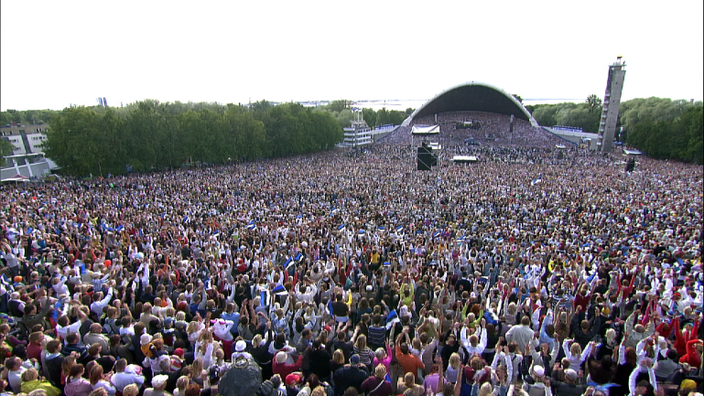
Illustration 9 Song celebration
Rather, it is the unique combination of the sublimity of music and human warmth that a rather distrustful northern nation dares to show during Song Celebrations, much to the surprise of others and its self..
Song and Dance Celebration – this is a joy. Because Song Festivals are irreplacable and unique, they can only be experienced on site.
The next nationwide Song and Dance Celebration will be in 2014 and the next Youth Song and Dance Celebration will be in 2017!
(Eesti Laulu- ja Tantsupeo SA, 2014)

History
The 1860s marked the beginning of a period of National Awakening. The Song Celebration tradition began with the first Song Celebration organized by Johann Voldemar Jannsen and the “Vanemuine” society in Tartu from 18-20 June 1869. 51 male choirs and brass bands encompassing 845 singers and musicians gathered in Tartu.
The first Song Celebration was high point fot the Estonian national movement. The Song Celebration was also great musical event, which created the Song Celebration tradition. The Song Celebration have taken place regardless of the political situation. The term “singing nation” expresses well the Estonian identity that has united the nation in its struggle for national independence before 1918 and during the period of the Soviet Occupation (1941-1991).
Six Song Celebratins were held from 1879-1910, which played and important role in the nation’s cultural and economic awakening and growth. The tradition of holding Song Celebrations every five years began during the first Estonian independence (1923-1938). Following the end of World War II, the Song Celebration tradition began again in 1947. Since 1950, the Song Celebratios have been held every five years.
The “Singing Revolution” began in 1988, based on the Song Celebration tradition, when hundreds of thousands of people gathered in the Song Festival Grounds to make political demands and sing patriotical songs.
The first Estonian Games, Dance and Gymnastics festival, held in 1934, was precursor of the present Dance Celebration. 1500 folk dancers performed there.
The greatest Dance Celebration of all times (the 9th) took place in 1970 with over 10000 performers. By then a structure based age groups had developed with performers including toddler and seniors, the dancing veterans. The youngest dancer at this festival was 4 years old and the oldest 76! All the following festivals have had the optimal 8000 performers.
The Dance Celebration is a complete performance with a certain theme. The dancers in their bright national costumes from several colourful patterns on the dance field. The Dance Celebration is usually held on the same weekend as the Song Celebration. These two celebrations commence with a united festive parade through the city from the centre of Tallinn to the Song Festival Grounds.
In the beginning of the 1960s, the number of youth choirs, orchestras, folk-dance groups and participants had increased to such a level that there arose a need for a separate celebration. So, it was decided that a Youth Song and Dance Celebration should be organized. The first was held in 1962 and the next celebration will be held in 2017.
In November 2003, UNESCO declared Estonias’s Song and Dance Celebration tradition a masterpiece of the Oral and Intangible Heritage of Humanity.
In July 2004 about 100 000 people participated in the XXIV Song Celebration and the XVII Dance Celebration, either as performers pr spectators. For the first time in the history of the festival, the dance performace and the official parade were cancelled due to strong rain, however, 7000 people organized a spontaneous parade.
(Eesti Laulu ja Tantsupeo SA, 2014)

