CHAOTIC SYSTEMS

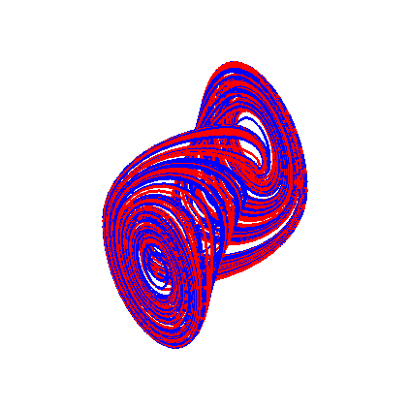
The Double Scroll Attractor
4. CHAOTIC SYTEMS

4.0 INTRODUCTION

Recall that for autonomous systems in the plane the Poincaré-Bendixson theorem essentially states that the only attractors which can exist are point attractors (stable nodes and foci) or stable limit cycles. This is no longer true if the system is either an autonomous system in three (or more) dimensions or a non-autonomous system in the plane. In this chapter we shall investigate the behaviour of both types of systems.

Before beginning our investigation it is important to note some of the results which carry over from planar autonomous systems and those which do not:

- The Hartman-Grobman theorem carries over;
- The method of examining dynamical behaviour using Lyapunov functions carries over with minor modifications;

but

- The classification of equilibrium points into nodes, foci, centres and saddle points does not carry over;
- The trace and determinant of the Jacobian matrix do not allow deductions about the stability of equilibrium points in the same way as for planar systems, it is necessary to examine the real part of the eigenvalues.

Basically the method of analysis models that of systems in the plane:

- Determine the equilibrium points;
- Linearise the system about each equilibrium point in turn;
- Examine the real part of the eigenvalues of the Jacobian matrix and apply the results of the Hartman-Grobman theorem.

Note that the characteristic polynomial of the Jacobian matrix is now a cubic which takes the form

where tr and det are the trace and determinant of the Jacobian matrix J and sp is defined below:

where are the eigenvalues of J.

The characteristic polynomial must have either three real roots or one real root and two conjugate complex roots. In the former case if the roots are then the characteristic polynomial can be written in the form

In the latter case if the roots are then the characteristic polynomial can be written in the form

Often these results can be used to make deductions about the stability of the equilibrium points. For example one immediate deduction is that if then the characteristic polynomial must have at least one real positive eigenvalue and hence the equilibrium point must be unstable. Other properties of the cubic including Cardan’s method of solution are given in Appendix 1.

  - THE LORENZ SYSTEM

The celebrated dynamical system due to Lorenz which describes the motion of a fluid in a horizontal layer which is being heated from below has the form

where x represents the velocity, y and z the temperature of the fluid and are positive parameters determined by the heating of the fluid, the physical properties of the fluid and the height of the layer.

The equilibrium points of the system are easily shown to be

The Jacobian matrix of the system is given by

and hence at the equilibrium point at the origin we obtain

In this case we can obtain meaningful expressions for the eigenvalues

Note that the eigenvalues are all real.

- For it is clear that all the eigenvalues are negative so from the Hartman-Grobman theorem we can deduce that the equilibrium point at the origin is stable.
- For one of the eigenvalues is positive so from the Hartman-Grobman theorem we can deduce that the equilibrium point is unstable.
- For one of the eigenvalues is zero so the Hartman-Grobman tells us nothing about the nature of the equilibrium point.

Now consider the equilibrium points . The Jacobian matrix is given by

In this case calculating the eigenvalues directly produces no usable result. Instead consider the characteristic polynomial which can be shown to be

for both equilibria.

Note that, since for the equilibria to exist, the coefficients of the cubic are all positive. This implies that the polynomial cannot have a positive real root and hence there can only be instability if there are two complex conjugate roots of the polynomial with positive real part.

Now for the characteristic polynomial reduces to

whose roots are

Since one of the roots is zero we cannot deduce anything about stability. However if r is slightly greater than one the first root will be non-zero but small and satisfy the equation

However we can ignore the terms in compared with that in and hence

The other two roots will change by a small amount but remain negative. All three roots are thus real and negative for r slightly greater than one and hence by the Hartman-Grobman theorem the equilibrium point will be stable.

As instability can only set in where and hence . But

Substituting for into the characteristic polynomial

Thus

So instability can only arise if and b are such that .

- Worked Example 1

Show that the equilibrium point at the origin is asymptotically stable for by using the Lyapunov function .

is clearly positive definite and hence has a local minimum at the origin. Now on a trajectory

which is negative definite for and negative semi-definite for only vanishing on the line which is not a trajectory of the system. Hence the equilibrium point at the origin is asymptotically stable for .

- Worked Example 2

Show that at the eigenvalues of the Jacobian matrix at the equilibrium points
are

Since at the complex eigenvalues have zero real part we have from the result in the introduction

Comparing with the characteristic polynomial

Thus

- Worked Example 3

Show that there is an ellipsoidal trapping region of the form

for the Lorenz equations.

Consider the function

On a trajectory

Thus if

Hence choose C large enough so that this last inequality is satisfied.

Challenge: Find the least value of C so that this is the case.

Exercises 1

- Show that the Lorenz equations are invariant under the transformation .

- Show that the linearisation of the Lorenz system about the equilibrium point at the origin is given by

Investigate the stability of the uncoupled equations for x and y.
- Show that all the trajectories of the Lorenz system eventually enter and remain in the spherical trapping region

for C sufficiently large.

4. Show that the transformation

where transforms the Lorenz system into the system

where ‘ refers to differentiation with respect to . Show that for large r

for constants of integration A and B. Hence deduce that

where

and C is another constant.
4.1.1 PHASE SPACE

The original parameter values used by Lorenz were . For these values of and r the critical value of r is given by .

Now consider the numerical solution of the system with initial conditions . The following phase plot and time series plot for x against t are obtained.

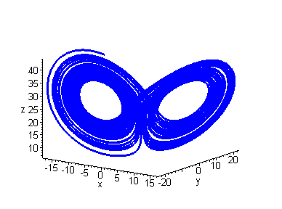
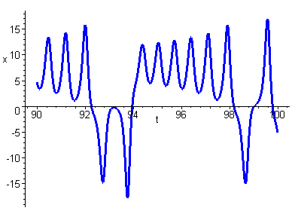

Note that the solution trajectories encircle first one equilibrium point and then the other. This pattern of motion is repeated endlessly with the trajectories being confined to a strange attractor. The time series plot indicates the apparently random nature of the motion.

Increasing to results in much the same type of behaviour. The plot below shows a different view of the strange attractor.
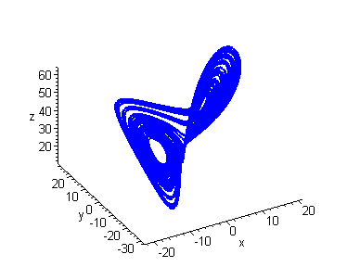

Note that on the attractor the trajectories never repeat the same path but remain confined to a finite region of phase space. It can be shown that the attractor is fractal in nature with a dimension lying between 2 and 3.

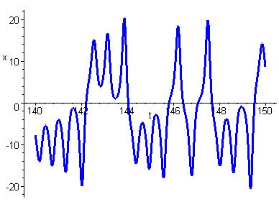
Changing the initial condition on x to we obtain the plot

Note that the two plots are completely different despite the very small (0.1%) change in the initial condition for x. This type of behaviour in which a small change in the initial conditions can produce a large change in subsequent values is called sensitive dependence on initial conditions also commonly referred to as the butterfly effect. This is a characteristic of chaotic dynamical systems.

For large values of r the strange attractor disappears and we obtain a stable limit cycle. For example the following plots show the behaviour at .

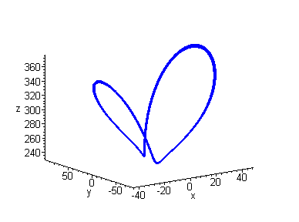
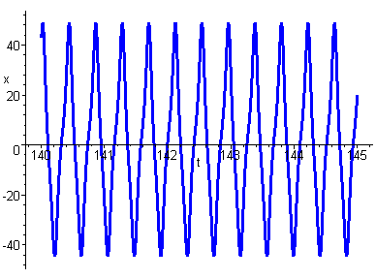

showing the existence of a stable limit cycle.

For smaller values of r we obtain other types of periodic attractors. For example at we obtain an attractor with a double period.

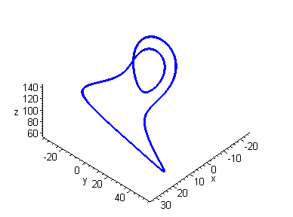

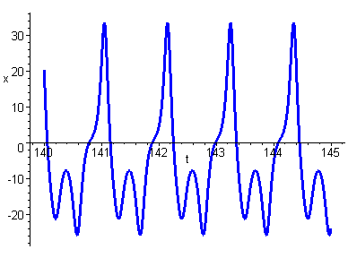

For values of r less than the critical value we can obtain transient chaos in which the trajectories begin by encircling the two stable equilibria but eventually become attracted to one of the two equilibrium points. For example at for initial conditions we obtain

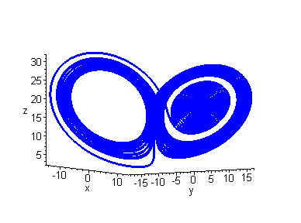
For values of r close to the critical value we obtain co-existence of the strange attractor and stable equilibria.

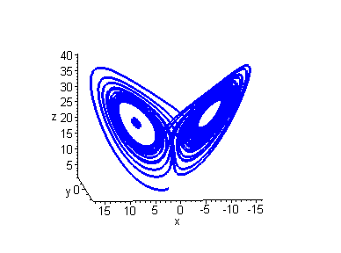
The plot shows the trajectories for two sets of initial conditions, one close to one of the equilibrium points. The small spiral on the left is attracted to that equilibrium point.

Exercises 2

- Investigate the behaviour of the Lorenz equations for parameter values and
- ,
- ,

- Investigate the behaviour of the Lorenz equations for parameter values and .

  - THE RÖSSLER SYSTEM

The dynamical system

was constructed by the Swiss mathematician Otto Rössler as the minimum system required to exhibit chaos. Note that the autonomous system only has one nonlinear term, in the third equation. Despite its simplicity this system is much harder to analyse than the Lorenz system.

Equilibrium Points

Clearly from the first two equations we have

Substituting into the third equation

giving equilibria at

Note that these equilibria only exist provided that .

Linearisation

The Jacobian matrix is given by

Substituting the coordinates of the equilibria we obtain

and hence at the first equilibrium point

and hence by the result in the introduction this equilibrium point is unstable.

Since for the second equilibrium point

we cannot use this result to deduce anything about the stability. In fact depending on the parameter values the equilibrium point can be stable or unstable.

4.2.1 PHASE SPACE

We shall fix the parameters and explore the behaviour of the system as c is increased from 2.5 to 5.

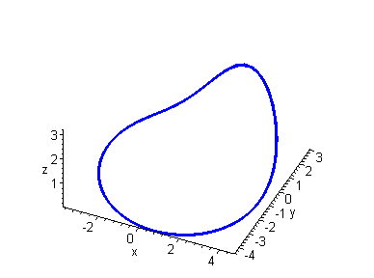
Limit Cycle

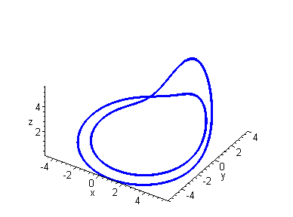
Period Doubling

The attractor has undergone a period doubling in which the attractor consists of two loops which are both traversed before the motion is repeated. This behaviour can be clearly seen from the time series plot.

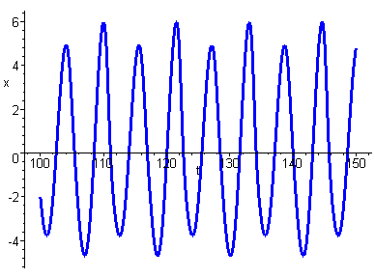

Notice that there are two distinct sets of peaks and troughs and the period of the motion is approximately twice that of the limit cycle.

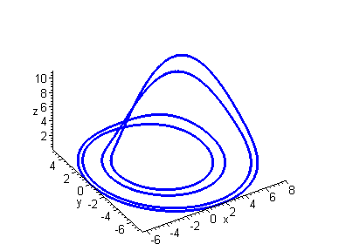
Further Period Doubling

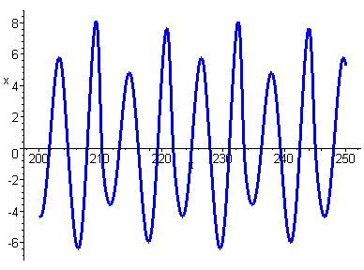

Now we have a further period doubling with four distinct sets of peaks and troughs.

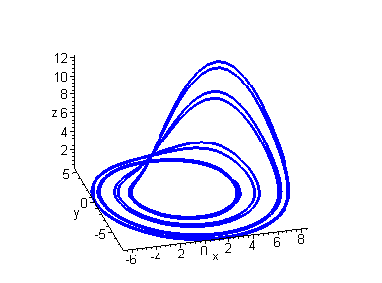
Further Period Doubling

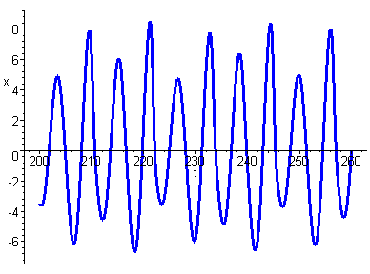

Now we have eight distinct sets of peaks and troughs and a further period doubling. This period doubling continues as we increase c. However a point is reached at which period doubling ceases and we obtain a strange attractor. This could be thought of a periodic attractor with infinite period.

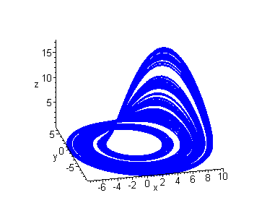
Strange Attractor

The behaviour of the Rössler system illustrated above is characteristic of many dynamical systems which exhibit chaos. The behaviour is often referred to as a period doubling cascade.

Exercises 3

1. For the Rössler system

show that in the case the system has one equilibrium point at and that the eigenvalues of the linearised system about this equilibrium point are given by

- A strange attractor is often defined to be one for which there is sensitive dependence on initial conditions. Demonstrate that this is the case for the Rössler system for parameter values .

- Investigate the behaviour of the Rössler system for . Does the strange attractor persist? If not what behaviour do you observe?

- Investigate the behaviour of the Rössler system for and a increasing in small steps from 0 to 0.4. Find the approximate value of a for which a Hopf bifurcation takes place.

5. The system of differential equations

arises in the modelling of the reversal of the earth’s magnetic field.

(a) Prove that the system has equilibrium points at

where

(b) Show that the eigenvalues of the linearised system are

What can we conclude about the stability of the nonlinear system?

(c) Investigate the behaviour of the system when for a range of values of k.
  - NON-AUTONOMOUS SYSTEMS

Thus far we have examined the occurrence of chaos in autonomous systems of differential equations of dimension greater than two. Although the Poincaré-Bendixson Theorem guarantees that chaos cannot occur in autonomous systems of dimension two this is not necessarily true for non-autonomous systems. To investigate the occurrence of chaos in such systems consider the equation below

This equation can be rewritten as an autonomous first order system by using the transformations resulting in the autonomous system of three equations

Notice that the system contains all the features necessary for the occurrence of chaotic behaviour i.e. it is a nonlinear autonomous system in three dimensions. The system has no equilibria in three dimensions since is never equal to zero. In plotting the trajectories of the system it is only necessary to consider the projection onto the x-y plane since the variable z has only been introduced as a device to make the system autonomous. Note that the resulting plot is not a true phase portrait of the system.

The system exhibits extremely complex behaviour and some features will be investigated in the exercises. Here we consider the behaviour of the system for and increasing values of B.

(a)

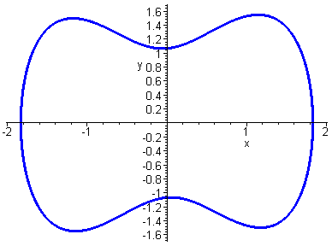

Limit Cycle

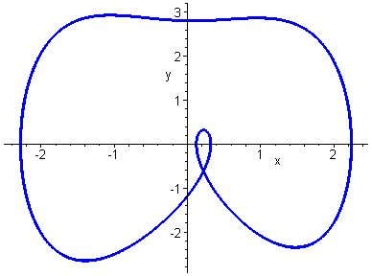

Periodic Attractor

(c)

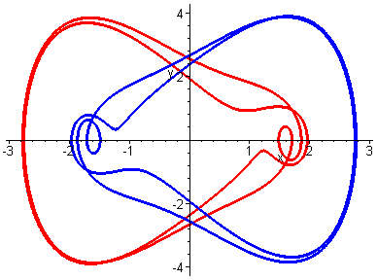

Two Periodic Attractors

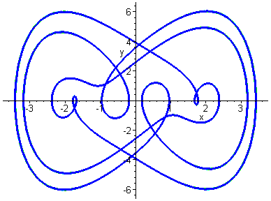

Single Periodic Attractor

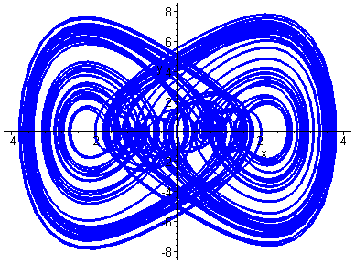

Strange Attractor

Exercises 4

- Show that the system studied above has five distinct periodic attractors for parameter values .

- Investigate sensitive dependence on initial conditions for the strange attractor in the above system.

- Show that for parameter values two periodic solutions co-exist with a strange attractor.

    - THE POINCARÉ SECTION

A powerful method for examining the motion of dynamical systems is that of a Poincaré section. Let

be a dynamical system in n-dimensions. Let S be an n-1 dimensional surface or section transverse to the trajectories of the system. Consider a point on S at time . As the trajectory starting at evolves it will eventually return to S at after a certain period . If we consider all initial points on S we can define a mapping P from S to itself such that

and in general after intersections

The mapping P is called the return map or Poincaré map of the dynamical system.

Now suppose that the dynamical system has a periodic attractor. Then clearly if the period of the attractor is T and we start at a point on the attractor, in S, then after time T the trajectory will return to and hence

and thus is a fixed point of P.

We can use this method to investigate the behaviour of the forced Brusselator in the following way. Choose a Poincaré section consisting of the x-y plane. Choose a strobe frequency which is hopefully the period of a potential periodic attractor. Only plot points in the x-y plane corresponding to a time interval . If we ignore transients, actually have a periodic attractor and have the correct strobe frequency we should only observe one plotted point in the x-y plane.

If the natural frequency of the system is and then we will obtain q points. If the natural frequency is an irrational multiple of the strobe frequency we will obtain a closed curve on the Poincaré section.

If we do not in fact have a periodic attractor but a chaotic attractor the Poincaré section will be fractal in nature.

Below are some Poincaré sections for different values of the parameter B in the system considered above. In each case the strobe frequency was chosen to be equal to the forcing frequency.

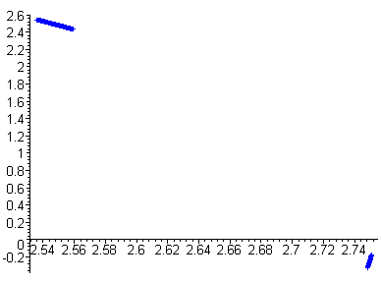

Recall that the plot of trajectories showed periodic behaviour. This is verified by the Poincaré section.

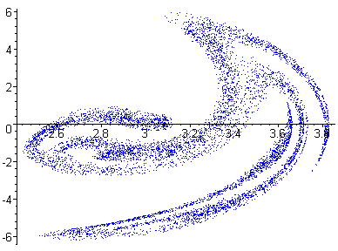

In this case the plot of trajectories suggested that there was a strange attractor. The Poincaré section shows a fractal attractor known as the Ueda Attractor.

Exercises 5

- Investigate the Poincaré section for parameter values . Do the results conform to the behaviour suggested in Exercises 4, Q 3?

2. For and starting with initial condition a periodic attractor is obtained. Determine the Poincaré section of the attractor using a strobe frequency of one. How many points are there on the Poincaré section? Explain.
4.4 CASE STUDY CHUA ELECTRICAL CIRCUIT

The dynamical system

where

represents a mathematical model of an LRC circuit consisting of a linear resistance, two linear capacitances, a linear inductance and a non-linear diode. The parameters of the system satisfy , .

At an equilibrium point

thus

If then and

If then and

If then and

Thus we have three equilibrium points

The Jacobian matrix is given by

At the origin thus

and the characteristic polynomial is

Thus and hence the equilibrium point is unstable.

At the other two equilibria thus

and the characteristic polynomial is

If we assume that then all the coefficients of the characteristic polynomial are positive and hence cannot have a positive real root. Thus if there is a bifurcation from stability to instability it must occur when the real part of a complex root changes from negative to positive.

But it can be shown that at the cubic has complex roots. Thus using the result that the polynomial can be written in the form

Hence

and since the real eigenvalue the real part of the complex eigenvalue and hence the equilibrium point is unstable. This means that stability can only set in if the real part becomes negative. Hence at the critical value

Substituting into the characteristic polynomial we obtain

Solving for

and hence the equilibrium point will become stable for values of greater than this.

    - SIMULATION

Taking parameter values the critical value of .

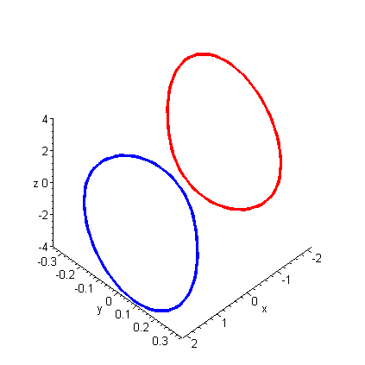
Pair of Limit Cycles

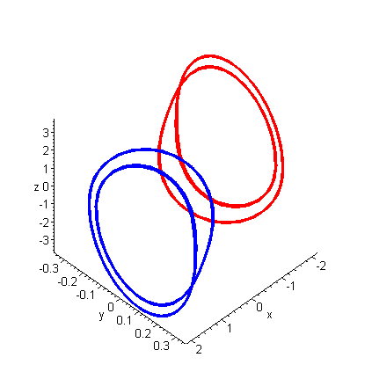
Period Doubling

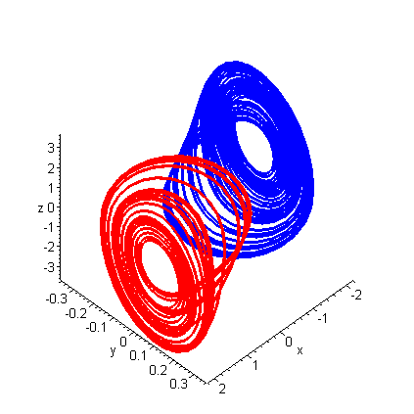
Two Strange Attractors

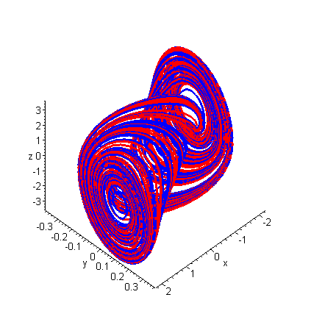
The Double Scroll Attractor
APPENDIX 1

CASE STUDIES
The Chua Electrical Circuit

The dynamical system

where

represents a mathematical model of an LRC circuit consisting of a linear resistance, two linear capacitances, a linear inductance and a non-linear diode. The parameters of the system satisfy , .

(a) Show that the system has three equilibrium points given by

(b) Show that the characteristic polynomial of the linearisation matrix for the equilibrium point at the origin is

Hence deduce that the equilibrium point is unstable.

(c) Show that the characteristic polynomial of the linearisation matrix for the remaining two equilibrium points is given by

Show that for the equilibria are unstable.
Deduce that if there is a critical value of given by

above which the second and third equilibrium points become stable.

(d) Use Maple to investigate the phase portrait of the system for parameter values and varying . In particular you should be able to detect the occurrence of pairs of stable foci, limit cycles, period doubling, strange attractors and finally a coalescence of the pair of strange attractors into a single strange attractor (the double scroll). Illustrate sensitive dependence on initial conditions.
The Double Well Oscillator

The differential equation

where are parameters with , representing mechanical oscillations with a non-linear spring, is known as the double well oscillator.

(a) Rewrite the differential equation as a system of first order equations and determine the equilibrium points for the cases and .

(b) Determine the nature of the equilibrium points in (a).

(c) Consider now the forced form of the equation

Write this differential equation as a first order autonomous system.

(d) Use Maple to investigate the phase portrait of the system in (c) for parameter values and varying . In particular you should be able to detect the occurrence of pairs of limit cycles, single limit cycles, other periodic attractors, strange attractors and co-existing limit cycles and strange attractors.

(e) Obtain Poincaré sections in the x-y plane using a strobe frequency for the periodic and strange attractors obtained in (d).
APPENDIX 2

ANSWERS AND HINTS

FOR THE EXERCISES

Lorenz System

Exercises 1

- Transform the equations using .
- Since equilibrium point is at the origin omit the nonlinear terms. hence saddle if and stable node for .
- Evaluate and show that it is negative outside a certain ellipsoid. Then take C large enough so that the sphere encloses the ellipsoid.
- Solve the transformed system for .

Exercises 2

1. (a) Stable focus;
(b) Transient chaos;
(c) Stable focus plus strange attractor;
(d) Periodic attractor;
(e) Another periodic attractor;
(f) Limit cycle.

- Period doubling.

Rössler System

Exercises 3

- Find eigenvalues of Jacobian matrix at .
- Choose two sets of initial conditions which are close together and plot resulting time series for one of the variables against t.
- Strange attractor does not persist. Obtain a variety of periodic and strange attractors.
- Obtain a supercritical Hopf bifurcation at .
- Let and solve third and second equations for y and z. Substitute into the second equation to show that . Find Jacobian matrix in terms of k. There is a Lorenz like strange attractor for e.g. .

Non-Autonomous Systems

Exercises 4

- Use five sets of initial conditions and .
- Choose two sets of initial conditions which are close together and plot resulting time series for x against t.
- Choose two sets of initial conditions.

Poincaré Sections

Exercises 5

- Yes.
- There are three points. The attractor has a frequency of .
APPENDIX 3

MAPLE WORK SHEETS
Lorenz System Analysis

Restart Maple and load the linear algebra package.

> restart:
> with(linalg):

Define the r.h.s. of the system.

> f:=sigma*(y-x):g:=r*x-y-x*z:h:=x*y-b*z:

Find the equilibrium points.

> eps:=solve({f,g,h},{x,y,z});
> ep1:=eps[1];
> eps2:=allvalues(eps[2]);
> ep2:=eps2[1];
> ep3:=eps2[2];

Find the Jacobian matrix at each equilibrium point.

> u:=[f,g,h]:
> J:=jacobian(u,[x,y,z]);
> J0:=subs(ep1,evalm(J));
> cp0:=collect(charpoly(J0,lambda),lambda);
> evs:=eigenvals(J0);
> ev1:=evs[1];
> ev2:=evs[2];
> ev3:=evs[3];
> J1:=subs(ep2,evalm(J));

Find the characteristic polynomial.

> cp2:=collect(charpoly(J1,lambda),lambda);
> J2:=subs(ep3,evalm(J));

Same characteristic polynomial as previous equilibrium point.
.
> cp3:=collect(charpoly(J2,lambda),lambda);
Simulation of the Lorenz System

Restart Maple and load the linear algebra package.

> restart:
> with(DEtools):

Define r.h.s. of equations.

> f:=sigma*(y(t)-x(t)):g:=r*x(t)-y(t)-x(t)*z(t):h:=x(t)*y(t)-b*z(t):

Set parameter values.

> sigma:=10:b:=8/3:
> r:=24.1:

Define differential equations.

> de1:=diff(x(t),t)=f:de2:=diff(y(t),t)=g:de3:=diff(z(t),t)=h:

Define initial conditions.

> ics:=[[0,1,1,1],[0,7,7,22]]:

Obtain phase plot. In this case we have co-existence of strange attractor and stable focus.

> DEplot3d([de1,de2,de3],[x(t),y(t),z(t)],t=0..150,ics,stepsize=0.01,linecolour=blue);
> r:=22:
> de1:=diff(x(t),t)=f:de2:=diff(y(t),t)=g:de3:=diff(z(t),t)=h:

Define initial conditions.

> ics:=[[0,5,5,7.5]]:

Obtain phase plot. In this case we have transient chaos..

> DEplot3d([de1,de2,de3],[x(t),y(t),z(t)],t=0..150,ics,stepsize=0.01,linecolour=blue);
> r:=40:
> de1:=diff(x(t),t)=f:de2:=diff(y(t),t)=g:de3:=diff(z(t),t)=h:

Define initial conditions.

> ics:=[[0,1,1,1],[0,1.001,1,1]]:

Plot time series to show sensitive dependence on initial conditions.

> DEplot([de1,de2,de3],[x(t),y(t),z(t)],t=140..145,ics,stepsize=0.01,
linecolour=[blue,green],scene=[t,x],maxfun=-1);
Worked Example 1

Restart Maple.

> restart:

Define the r.h.s. of the system.

> f:=sigma*(y-x):g:=r*x-y-x*z:h:=x*y-b*z:

Define the Lyapunov function.

> V:=x^2+sigma*y^2+sigma*z^2:

Obtain dV/dt on trajectories.

> dV:=simplify(diff(V,x)*f+diff(V,y)*g+diff(V,z)*h);

Worked Example 3

Restart Maple and load the plots package.

> restart:
> with(plots):

Define the r.h.s. of the system.

> f:=sigma*(y-x):g:=r*x-y-x*z:h:=x*y-b*z:

Define the Lyapunov function.

> V:=r*x^2+sigma*y^2+sigma*(z-2*r)^2:

Obtain dV/dt on trajectories.

> dV:=simplify(diff(V,x)*f+diff(V,y)*g+diff(V,z)*h);

As an example take sigma = 10;, b = 8/3;, r = 40;. Then plot V=C and the ellipsoid x^2/(b*r)+y^2/(b*r^2)+(z-r)^2/(r^2) = 1+epsilon; for a small value of epsilon.

> sigma:=10:b:=8/3:r:=40:
> W:=x^2/(b*r)+y^2/(b*r^2)+(z-r)^2/(r^2):
> implicitplot3d({V=61000,W=1.0001},x=-30..30,y=-70..70,z=0..160);
Rossler Analysis

Restart Maple and load the linear algebra package.

> restart:
> with(linalg):

Define the r.h.s. of the system.

> f:=-y-z:g:=x+a*y:h:=b-c*z+x*z:

Find the equilibrium points.

> _EnvExplicit:=true;
> eps:=solve({f,g,h},{x,y,z});
> ep1:=eps[1]:
> ep2:=eps[2]:

Carry out the linearisation.

> u:=[f,g,h]:
> J:=jacobian(u,[x,y,z]);
> J1:=subs(ep1,evalm(J));
> J2:=subs(ep2,evalm(J));

Determine the characteristic polynomial for the first equilibrium point.

> cp1:=collect(charpoly(J1,lambda),lambda);

Evaluate the determinant.

> det(J1);

Shows the instability of the first equilibrium point.
Simulation of the Rossler System

Restart Maple and load the linear algebra package.

> restart:
> with(DEtools):
> f:=-y(t)-z(t):g:=x(t)+0.2*y(t):h:=0.2-c*z(t)+x(t)*z(t):

Explore phase space for a range of values of c.

> c:=2.5:
> de1:=diff(x(t),t)=f:de2:=diff(y(t),t)=g:de3:=diff(z(t),t)=h:
> ics:=[[0,1,1,1]]:
> DEplot3d([de1,de2,de3],[x(t),y(t),z(t)],t=100..150,ics,stepsize=0.1,linecolour=blue);
> c:=3.0:
> de1:=diff(x(t),t)=f:de2:=diff(y(t),t)=g:de3:=diff(z(t),t)=h:
> ics:=[[0,1,1,1]]:
> DEplot3d([de1,de2,de3],[x(t),y(t),z(t)],t=100..150,ics,stepsize=0.1,linecolour=blue);
> DEplot([de1,de2,de3],[x(t),y(t),z(t)],t=100..150,ics,stepsize=0.1,
linecolour=blue,scene=[t,x]);
> c:=4:
> de1:=diff(x(t),t)=f:de2:=diff(y(t),t)=g:de3:=diff(z(t),t)=h:
> ics:=[[0,1,1,1]]:
> DEplot3d([de1,de2,de3],[x(t),y(t),z(t)],t=200..250,ics,stepsize=0.05,
linecolour=blue);
> DEplot([de1,de2,de3],[x(t),y(t),z(t)],t=200..250,ics,stepsize=0.05,
linecolour=blue,scene=[t,x]);
> c:=4.2:
> de1:=diff(x(t),t)=f:de2:=diff(y(t),t)=g:de3:=diff(z(t),t)=h:
> ics:=[[0,1,1,1]]:
> DEplot3d([de1,de2,de3],[x(t),y(t),z(t)],t=200..250,ics,stepsize=0.05,
linecolour=blue);
> DEplot([de1,de2,de3],[x(t),y(t),z(t)],t=200..260,ics,stepsize=0.05,
linecolour=blue,scene=[t,x]);
> c:=5:
> de1:=diff(x(t),t)=f:de2:=diff(y(t),t)=g:de3:=diff(z(t),t)=h:
> ics:=[[0,1,1,1]]:
> DEplot3d([de1,de2,de3],[x(t),y(t),z(t)],t=500..1000,ics,stepsize=0.05,
linecolour=blue);
> DEplot([de1,de2,de3],[x(t),y(t),z(t)],t=200..260,ics,stepsize=0.05,
linecolour=blue,scene=[t,x]);
Non-Autonomous Systems Simulation

Restart Maple and load the DEtools package.

> restart:
> with(DEtools):

Define r.h.s. of the dynamical system.

> f:=y(t):g:=-k*y(t)-x(t)^3+B*cos(z):h:=1:

Set parameter values.

> k:=0.1:B:=2:

Define differential equations.

> de1:= diff(x(t),t)=f:
> de2 := diff(y(t),t)=g:
> de3 := diff(z(t),t)=h:

and initial conditions.

> ics:=[[0,1,0,0]]:

Plot the trajectories

> DEplot([de1,de2,de3],[x(t),y(t),z(t)],t=300..400,ics,stepsize=0.05,scene=[x,y],
linecolour=blue);

Repeat for other values of B. Notice that sometimes we need to use more than one initial condition to obtain an accurate plot.

> B:=5:
> de1:= diff(x(t),t) = f:
> de2 := diff(y(t),t)=g:
> de3 := diff(z(t),t)=h:
> ics:=[[0,1,0,0],[0,-1,0,0]]:
> DEplot([de1,de2,de3],[x(t),y(t),z(t)],t=300..400,ics,stepsize=0.05,scene=[x,y],
linecolour=[blue,red]);
> B:=9:
> de1:= diff(x(t),t) = f:
> de2 := diff(y(t),t)=g:
> de3 := diff(z(t),t)=h:
> ics:=[[0,1,0,0],[0,-1,0,0]]:
> DEplot([de1,de2,de3],[x(t),y(t),z(t)],t=300..400,ics,stepsize=0.05,scene=[x,y],
linecolour=[blue,red]);
> B:=10:
> de1:= diff(x(t),t) = f:
> de2 := diff(y(t),t)=g:
> de3 := diff(z(t),t)=h:
> ics:=[[0,1,0,0],[0,-1,0,0]]:
> DEplot([de1,de2,de3],[x(t),y(t),z(t)],t=300..400,ics,stepsize=0.05,scene=[x,y],
linecolour=[blue,red]);

Poincare Sections

This worksheet shows how to use Maple to obtain a Poincare section. Note that these plots can take a long time.

Restart Maple and load the plots package.

> restart:
> with(plots):

Define the system. Note that we do not need to make the system autonomous here.

> f:=y(t):g:=-k*y(t)-x(t)^3+B*cos(t):

Choose the parameter values.

> k:=0.1:B:=11:

Define the differential equations.

> de1:=diff(x(t),t)=f:
> de2:=diff(y(t),t)=g:

We need to use the numeric option in dsolve not DEplot. It is also best to use the gear method rather than the default numerical method. We have included the intial conditions explicitly in the command.

> ueda := dsolve({de1, de2, y(0)=1, x(0)=1}, {x(t), y(t)},type=numeric, method=gear):

We define the Poincare section to be a function of the number of points being plotted. The t-range for the plot is over one complete period of the plot time the number of points to be plotted. This ensures that a point will only be plotted when t reaches a complete period. Notice that in this case, since the frequency is one, one complete period is 2*Pi;. We start at 2*Pi*points to exclude transients and plot up to 4*Pi*points. In general if the frequency is omega; we would need to plot over a range of 2*Pi/omega;.

> poincare:=(points)->odeplot(ueda, [x(t),y(t)], (2*Pi*points)..(4*Pi*points),numpoints=points,style=point,symbol=point,
colour=blue):
> poincare(2000);

The Chua Electrical Circuit

Restart Maple and load the necessary packages.

> restart:

> with(linalg):

> with(DEtools):

Define the system.

> p:=x->m1*x+(m0-m1)/2*(abs(x+1)-abs(x-1));

> f:=c1*(y-x-p(x)):g:=c2*(x-y+z):h:=-c3*y:

We need to make assumptions about the parameters for the maths to work.

> assume(c1>0,c2>0,c3>0,m0<-1,m1<0, m1>-1):

Find the equilibrium points.

> eps:=solve({f,g,h},{x,y,z});

Now carry out a linearization.

> A:=matrix(3,3,[diff(f,x),diff(f,y),diff(f,z),diff(g,x),diff(g,y),diff(g,z),

diff(h,x),diff(h,y),diff(h,z)]);

> A0:=map(simplify,subs(eps[2],evalm(A)));

> A1:=map(simplify,subs(eps[3],evalm(A)));

> A2:=map(simplify,subs(eps[1],evalm(A)));

Find the characteristic polynomials

> cp0:=collect(charpoly(A0,lambda),lambda);

Since m0<-1 the constant term is negative and hence there must be a positive real root. Thus E.P. is unstable.

> cp1:=collect(charpoly(A1,lambda),lambda);

With conditions on parameters polynomial has positive coefficients and constant term. Hence no positive real root. Proceed as in accompanying booklet to show there can only be a bifurcation when complex roots have zero real part.

> trA:=trace(A1);

> c3c:=solve(subs(lambda=trA,cp1),c3);

Note that stability is lost as the parameter decreases through the critical value.

Choose parameter values.

> c1:=15.6:c2:=1:m0:=-8/7:m1:=-5/7:

Obtain critical value

> c3c := -c1*m1/c2*(c2+c1*m1+c1);

Now vary the value of c3. Note the use of two i.c.s. Necessary to obtain the complete picture.

> c3:=65:

> de1:=diff(x(t),t)=f:

> de2:=diff(y(t),t)=g:

> de3:=diff(z(t),t)=h:

> ics:=[[x(0)=2,y(0)=0,z(0)=0],[x(0)=-2,y(0)=0,z(0)=0]]:

> DEplot3d({de1,de2,de3},[x(t),y(t),z(t)],t=50..100,ics,stepsize=0.05,

linecolour=[blue,red]);

Two stable foci

> c3:=45:

> de1:=diff(x(t),t)=f:

> de2:=diff(y(t),t)=g:

> de3:=diff(z(t),t)=h:

> ics:=[[x(0)=2,y(0)=0,z(0)=0],[x(0)=-2,y(0)=0,z(0)=0]]:

> DEplot3d({de1,de2,de3},[x(t),y(t),z(t)],t=50..100,ics,stepsize=0.05,

linecolour=[blue,red]);

Two limit cycles

> c3:=35:

> de1:=diff(x(t),t)=f:

> de2:=diff(y(t),t)=g:

> de3:=diff(z(t),t)=h:

> ics:=[[x(0)=2,y(0)=0,z(0)=0],[x(0)=-2,y(0)=0,z(0)=0]]:

> DEplot3d({de1,de2,de3},[x(t),y(t),z(t)],t=50..100,ics,stepsize=0.05,

linecolour=[blue,red]);

Period Doubling

> c3:=33.5:

> de1:=diff(x(t),t)=f:

> de2:=diff(y(t),t)=g:

> de3:=diff(z(t),t)=h:

> ics:=[[x(0)=2,y(0)=0,z(0)=0],[x(0)=-2,y(0)=0,z(0)=0]]:

> DEplot3d({de1,de2,de3},[x(t),y(t),z(t)],t=50..100,ics,stepsize=0.05,

linecolour=[blue,red]);

Another period doubling

> c3:=32:

> de1:=diff(x(t),t)=f:

> de2:=diff(y(t),t)=g:

> de3:=diff(z(t),t)=h:

> ics:=[[x(0)=2,y(0)=0,z(0)=0],[x(0)=-2,y(0)=0,z(0)=0]]:

> DEplot3d({de1,de2,de3},[x(t),y(t),z(t)],t=50..100,ics,stepsize=0.05,

linecolour=[blue,red]);

Two separate strange attractors

> c3:=30:

> de1:=diff(x(t),t)=f:

> de2:=diff(y(t),t)=g:

> de3:=diff(z(t),t)=h:

> ics:=[[x(0)=2,y(0)=0,z(0)=0],[x(0)=-2,y(0)=0,z(0)=0]]:

> DEplot3d({de1,de2,de3},[x(t),y(t),z(t)],t=50..100,ics,stepsize=0.05,

linecolour=[blue,red]);

Homoclinic orbit

> c3:=28:

> de1:=diff(x(t),t)=f:

> de2:=diff(y(t),t)=g:

> de3:=diff(z(t),t)=h:

> ics:=[[x(0)=2,y(0)=0,z(0)=0],[x(0)=-2,y(0)=0,z(0)=0]]:

> DEplot3d({de1,de2,de3},[x(t),y(t),z(t)],t=50..200,ics,stepsize=0.05,

linecolour=[blue,red]);

Double scroll attractor

Now plot the time series for two slightly different initial conditions.

> ics:=[[x(0)=2,y(0)=0,z(0)=0],[x(0)=2.001,y(0)=0,z(0)=0]]:

> DEplot({de1,de2,de3},[x(t),y(t),z(t)],t=100..150,ics,stepsize=0.05,

linecolour=[blue,red],scene=[t,x(t)]);

Sensitive dependence on initial conditions
APPENDIX 4

PROPERTIES OF THE GENERAL

CUBIC EQUATION

Cardan’s Solution

Consider the general cubic equation

Using the substitution

we obtain the transformed equation

where

Now choose p and q so that

then the solution of the cubic in y is given by

where are the complex cube roots of unity.

Note that this solution is usually far to complicated to be of any practical use but it can also be shown that the nature of the roots is determined by the discriminant

If then the cubic has one real and two complex conjugate roots;
If then the cubic has three real roots two being equal;
If then the cubic has three unequal real roots.

Notice that the last case requires that .

Other Useful Relationships

If the cubic has three real roots then it can be written in the form

If the cubic has one real roots and two complex roots then it can be written in the form

and if the cubic has one real roots and two imaginary roots then it can be written in the form

and we immediately know the roots.

