BIFURCATION DIAGRAMS AND CHAOS

Let us consider a dynamical system We assume that we have a family of functions where is a parameter. In particular, we can think of as a function of two numbers: and

A bifurcation is a sudden change in the number or nature of the fixed and periodic points of the system. Fixed points may appear or disappear, change their stability or even break apart into periodic points.

Bifurcation diagrams

For a dynamical system involving a parameter find all fixed points as functions of Plot these functions on the axis. Find ranges of for which each of these fixed points is attracting and draw vertical arrows towards them. In those same ranges, draw arrows away from repelling fixed points, and appropriate arrows for semistable fixed points. Also draw arrows either up or down for values of for which these are no fixed points.

- Worked Example 3

Consider the dynamical system

where is some fixed constant. The fixed points are solutions to the equation

Notice that, for all values, is a fixed point, while are fixed points only when Thus, if we have one fixed point, while if there are three fixed points.
Since
one has that

Thus is attracting when Likewise is repelling when and

To find the stability of we compute

It follows that both fixed points are attracting when

The bifurcation diagram is presented in the figure.

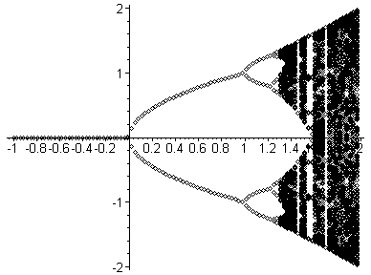

The critical value is called in this case a pitchfork bifurcation. The other important types of bifurcations are transcritical bifurcations (the fixed points lying on two intersecting curves) and saddle node bifurcations. In the latter case at the bifurcation value the fixed points form a U-shaped curve.

Chaos

Sometimes it happens that all the fixed points and cycles are repelling.

Suppose that a dynamical system
- is transitive on its attractor
- has sensitive dependence of initial values,
- has repelling cycles that are close to the attractor Then this dynamical system exhibits chaos.

Intuitively, a dynamical system exhibits chaos if in one sense there is unpredictability (sensitive dependence on initial values says we can not make precise predictions), but in another sense there is predictability (transitivity says we will be at a point, we just don't know when).

A set of points is called an attracting set or simply attractor for a dynamical system if there is a number such that if for some point then

For instance, when the dynamical system

has as an attracting fixed point. Thus the set is an attractor.

The dynamical system is said to be transitive if, when is close to some point in an attractor, then for every point in the attractor there is a subsequence of values that converge to that is

For instance, the dynamical system

having the attractor is not transitive.

The dynamical system fulfills the requirements (i)-(iii) and thus exhibits chaos.

