GEOMETRIC APPROACH TO STABILITY – COBWEB DIAGRAMS

Consider the dynamical system

Let the function be depected in the figure.

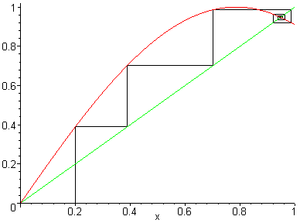

Draw a vertical line from the point lying on the horizontal axis until it intersects the graph of that height is the output At this stage we could return to the horizontal axis and repeat the procedure to get from but it is more convenient simply to trace a horizontal line till it intersects the diagonal line and then move vertically to the curve again. Repeat the process times to generate the first points in the orbit.

Cobwebs are useful because they allow us to see global behaviour at a glance, thereby supplementing the local information available from the linearisation.

Cobwebs become even more valuable when linear analysis fails.

