LIMIT CYCLES

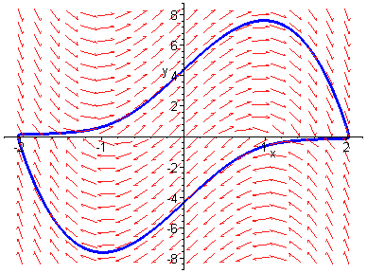

Limit Cycle of the Van der Pol Equation

3. LIMIT CYCLES

3.0 INTRODUCTION

Thus far in our study of dynamical systems the only type of attractors or repellers encountered have been point attractors or repellers i.e. stable nodes and foci or unstable nodes and foci. We shall now show that another type of attractor or repeller is possible for nonlinear systems, the limit cycle.

Polar Coordinates

Often it is advantageous to rewrite a dynamical system in polar coordinates when considering limit cycles. Recall the relationships between polar coordinates and cartesian coordinates

and the inverse relationships

Differentiating the former relationships with respect to t we obtain

and

Also at an equilibrium point

hence we must have either or .

Consider the system

In order to facilitate the analysis of the system we shall transform it into polar form. Recall that

Thus for our system

where . Similarly

and hence the polar form of the system is

From these results two obvious solutions are and . (Why is not a solution?). The first solution corresponds to an unstable focus at the origin. The second represents the polar form of the equation of a circle of radius one and centre the origin. The fact that implies that the circle is traversed in a clockwise direction with a constant angular velocity of one unit. Thus we have a solution of the system which is a closed orbit.. Notice that if then and trajectories spiral outwards towards the closed orbit. If then and trajectories spiral inwards towards the closed orbit.

Overall the trajectories approach an isolated closed orbit which we call a stable limit cycle.

Other types of limit cycles are possible. For example

represents a system with an unstable limit cycle. In this case if then and trajectories spiral inwards away from the closed orbit. If then and trajectories spiral outwards away from the closed orbit.

A third possibility is represented by the system

In this case we have a semi-stable limit cycle in which if then and trajectories spiral outwards towards the closed orbit. If then again and trajectories spiral outwards away from the closed orbit.

Exercises 1

1. Determine the nature of the limit cycles of the following sytems of differential equations given in polar form

(a)

(b)

(c)

- Show that the system is equivalent to

- Show that the dynamical system

where has a stable limit and state its equation.

3.1 TRAPPING REGIONS

It is not always possible to determine the existence of a limit cycle directly from the polar form as is illustrated in the following example.

- Worked Example 1

Show that the system

has a stable limit cycle which lies in the annular region

As before transform the equations into polar form to obtain

Note that the polar form does not immediately give a limit cycle. However consider . This implies that

But this must be true for all . This means that

since the maximum value of the expression

is when .

Now consider . This implies that

But this must be true for all . This means that

since the minimum value of the expression

is 1 when . These results imply that when and when . Now consider a trajectory which starts inside the annular region shown below.

Suppose that the trajectory touches the outer boundary. Then immediately and the trajectory is forced to remain in the annulus. Similarly if the trajectory touches the inner boundary then and once more the trajectory is forced to remain in the annulus. Thus any trajectory which starts inside the annulus is trapped within it. Such a region is called a trapping region.

The equilibrium points of the system are given by

Hence either r and or both But implies that

This cannot hold inside the region since. Hence there are no equilibrium points within the annulus. Intuitively since a trajectory cannot tend to an equilibrium point and cannot cross itself the trajectory must either be a closed orbit or eventually tend to a closed orbit. Hence there must be at least one limit cycle within the annulus.

Exercises 2

1. Find the polar form of the following systems of differenial equations.

(a)

(b)

(c)

- Find an annular trapping region for each of the systems in Q1.

3.2 POINCARÉ-BENDIXSON THEORY

The results of Worked Example 1 can be formalised in the following theorem.

Theorem - Poincaré-Bedixson

Let D be a closed bounded region of the x-y plane and

be a dynamical system in which f and g are continuously differentiable. If a trajectory of the dynamical system is such that it remains in D for all then the trajectory must be

(i) a closed orbit,
(ii) approach a closed orbit or
(iii) approach an equilibrium point as .

The implication of this theorem is that if we can find a trapping region for a dynamical system which does not contain an equilibrium point then there must be at least one limit cycle within the region. The technique of transforming to polar coordinates although often employed does not always work. The following examples demonstrates other methods of obtaining trapping regions.

- Worked Example 2

In the biochemical process of glycolis, living cells obtain energy by breaking down sugar molecules. Often this process turns out to be oscillatory in nature. A simple model of the process is described by the equations

where x and y are concentrations of reactants and a and b are positive parameters.
The diagram below shows the graphs of the expressions

and

on which and respectively. We shall show that the region within the dotted lines is a trapping region for the system.

On the x-axis

and hence and thus the trajectories must flow in the direction indicated by the arrow.

On the y-axis

and hence since , and the flow of the trajecories is as shown.

When

and hence for giving the direction of flow shown.

On the small vertical line hence

Thus since the line is below the curve . Also above the curve and below the curve . In both cases the flow is into the region.

Now choose k so that the diagonal line has slope -1. Consider

Now on the line and hence

and hence the trajectories are steeper than the line and hence must point into the region.

These results show that the region is a trapping region. However we cannot conlude that there is a limit cycle within region since the equilibrium point lies within the region. The Jacobian matrix of the linearzation is

Now and

If we choose the parameters a and b so that then the equilibrium point will be a repeller. In this case suuround the equilibrium point by a small circular region as shown below.

Since the equilubrium point is a repeller, trajectories crossing the boundary must point into the region defined by the dotted lines. In this case the new region is a trapping region which does not include an equilibrium point. Thus the Poincare´-Bendixson theorem guarantees that the region must contain at least one limit cycle. We can verify this result using Maple to obtain the phase portrait. Suitable parameter values are

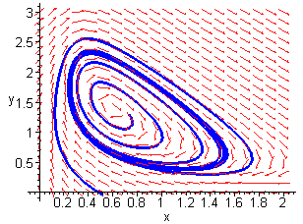
Limit Cycle

- Worked Example 3

By considering the rate of change with respect to time of the function

on the trajectories of the dynamical system

show that the dynamical system has a stable elliptical limit cycle.

It is easily seen that the only equilibrium point of the system occurs at the origin.

Now

Thus we see that V decreases on the trajectories except at the origin where it clearly has a relative maximum, and on the ellipse where it is identically zero.

Now consider the plot of V shown below.

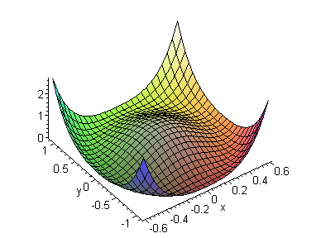

Outside the ellipse the function is decreasing towards the ellipse. Inside the ellipse the function is decreasing towards the ellipse again. Thus the trajectories of the system must move towards the ellipse from points outside and inside for increasing t. Now consider a contour plot of the function.

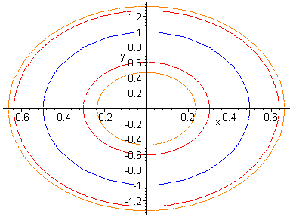

We can construct a trapping region by taking any contour inside the ellipse as the inner boundary of an annular region together with any contour outside the ellipse as the outer boundary. Hence by the Poincaré-Bendixson theorem since there are no equilibrium points within the annular region there must be a stable limit cycle within the region.

Note also that as the contours can be taken as close to the ellipse as we like the limit cycle must be the ellipse.

Exercises 3

- Use the Poincaré-Bendixson theorem to show that the systems of Exercise 1 of the previous examples have at least one lmit cycle.

- Show that the system

has a limit cycle.

3. By considering the level curves of the positive definite function
show that the nonlinear oscillator

.

has a stable limit cycle.

4. The following dynamical system is a simple model of a chemical oscillator

where a and b are positive parameters and are dimensionless concentrations.

(a) Show that the system has an equilibriun point at which is a repeller when ;
(b) by considering the curves given by show that there exists a trapping region for the system;
(c) use the Poincaré-Bendixson theorem to show that the system has at least one limit cycle.

3.3 LIÉNARD SYSTEMS

A great number of mathematical models of physical systems give rise to differential equations of rhe type

This is known as Liénard's equation. The system is a generalization of the mass-spring-damper system

previously encountered. In Liénard's equation is the damping term and is the spring term. The equation can be written as the planar system

Under certain conditions on f and g it can be shown that Liénard's equation has a limit cycle. This result is known as Liénard's Theorem.

Theorem - Liénard's Theorem

Suppose that f and g satisfy the conditions
(i) f and g are continuously differentiable;
(ii) g is an odd function i.e. ;
(iii) ;
(iv) f is an even function i.e. ;
(v) let and ,
, ();
then Liénard's equation has a unique stable limit cycle surrounding the origin.

The properties of the odd function F are indicated in the diagram below.

Use the graph to check the properties of F listed above.

- Worked Example 4

Show that the Van der Pol equation

where , has a stable limit cycle.

This is an example of Liénard's equation with

Checking the conditions of Liénard's Theorem we find that

(i) both f and g are continuosly differentiable;
(ii) is odd and obviously ;
(iii) and so f is even;
(iv)
,
, ().

The conditions are satisfied hence there exists a unique stable limit cycle surrounding the origin.

Van der Pol's equation arose from a 1926 mathematical model of an electrical circuit containing a thermionic valve. Valves were used in early radios and TVs. Careful observation of the damping term shows that for small x the oscillations are negatively damped and hence increase in amplitude. For large x the oscillations are positively damped and hence decrease in amplitude. Intuitively somewhere between these two extremes the damping must be zero resulting in an oscillation with constant amplitude. This is an isolated periodic solution and hence a limit cycle. The most interesting behaviour occurs for relatively large values of the parameter . The diagram below shows the phase portrait for the case .

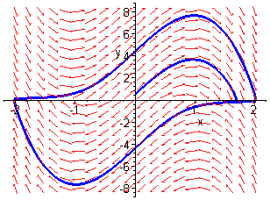

Notice that the limit cycle is very different from one resulting from sinusoidal oscillations. This can be seen clearly in the time series plots of x and y shown below.
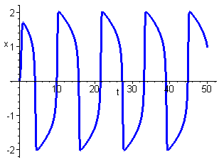

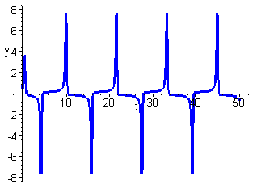

Exercises 4

1. Show that the equation

for has exactly one periodic solution and classify its stability.

2. Consider the equation

(a) Prove that the system has a unique limit cycle if ;
(b) plot the phase portrait for the case ;
(c) if does the system still have a limit cycle?

3.4 DULAC’S CRITERION

It is often useful to be able to rule out the existence of a limit cycle in a region of the plane. The following result due to Dulac sometimes enables us to do this.

Dulac's Criterion

Let D be a simply connected region of the phase plane. If there exists a continuously differentiable function such that

is of constant sign in D then the dynamical system

has no closed orbits wholly contained in D.

This method suffers from the same problem as finding Lyapunov functions in that it is often difficult to find a suitable function . Some possible choices for are

- Worked Example 5

Show that the system

has no closed orbits anywhere.

Let us try .

Although this shows that there is no closed orbit contained in either half-plane it does not rule out the existence of a closed orbit in the whole plane since there may be such an orbit which crosses the line .

Now let us try .

Choosing reduces the expression to which is negative everywhere. Hence there are no closed orbits.

Exercises 5

1. Show that the system

has no closed orbits.

- Show that the competing species model

where are positive parameters and has no periodic solutions.

3.5 THE HOPF BIFURCATION

The behaviour of a one-dimensional dynamical system may depend on the value of a certain parameter. As the parameter value passes through a critical value the system dynamics can change substantially. This is termed a bifurcation. Consider the following example.

- Worked Example 6

Investigate the effect of changing the parameter on the dynamical system

It can be shown that the polar form of the system is

from which it is clear that there is a single equilibrium point at the origin. The first polar equation can be written as

Clearly there is a limit cycle of radius in this case. Also the origin is unstable since for small r

which is positive.

If then and the origin is globally asymptotically stable. This behaviour is illustrated below for the cases and respectively.

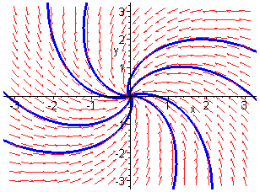
Stable Focus

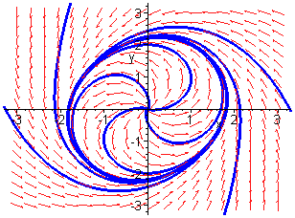
Unstable Focus + Stable Limit Cycle

We see that as the parameter passes through zero from negative to positive a stable focus gives way to an unstable focus surrounded by a stable limit cycle whose radius increases with . This is an example of a Hopf bifurcation.

In order to gain further insight into the behaviour of this system and to set the scene for the introduction of the principal result of this section let us carry out a linear stability analysis of the cartesian form of the equations. The linearization about the origin is obviously

The Jacobian matrix is therefore

The eigenvalues are given by

Solving gives

Thus if we have a stable focus, if an unstable focus and if we cannot decide (although we know from the polar form that we have a stable focus). As the bifurcation from a stable focus to an unstable focus surrounded by a stable limit cycle occurs the real part of the eigenvalues changes from negative to positive being zero at the bifurcation point. This is typical of this type of Hopf bifurcation which is said to be supercritical. The following theorem generalises these results.

Theorem - The Hopf Bifurcation Theorem

Suppose that the system

has an equilibrium point at the origin for all. In addition suppose that the eigenvalues of the linearization are purely imaginary when . If the real part of the eigenvalues satisfy

and the origin is asymptotically stable when then

(i) is a bifurcation point of the system;
(ii) for some such that the origin is a stable focus;
(iii) for some such that the origin is an unstable focus surrounded by a stable limit cycle whose size increases with .
In the previous example and . Also

and hence the theorem predicts the existence of the stable limit cycle.

- Worked Example 7

Investigate the behaviour of the system

as the parameteris varied.

This system has a single equilibrium point at the origin as you should verify. The linearization is clearly

which is identical to that found in Worked Example 6. This means that all the conditions of the Hopf bifurcation theorem are satisfied apart from the asymptotic stability of the origin at . This suggests that there may be a Hopf bifurcation. However the polar form of the equation for r is

which shows that the origin is unstable. Hence the theorem does not apply. Using Maple we obtain the following plots for and respectively.

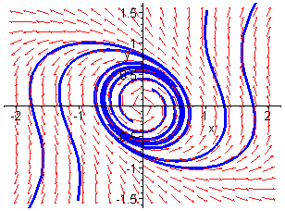
Stable Focus + Unstable Limit Cycle

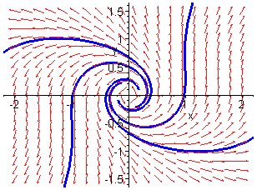
Unstable Focus

The first plot shows the existence of an unstabe limit cycle surrounding the stable focus at the origin The second plot shows the unstable focus which occurs when is positive. We have a different type of Hopf bifurcation which is referred to as subcritical.

- Worked Example 8

Show that the dynamical system

undergoes a subcritical Hopf bifurcation at for a certain range of values of the parameter a.

Clearly an E.P. at the origin.

Transforming to polar coordinates

Thus

Thus for ‘small’ values of r

and hence the equilibrium point is a stable focus if and an unstable focus if .

For

for ‘small’ r. Thus the origin is unstable.

Now we can factorise the expression for to obtain

If then are both real and positive so we can further factorise to obtain

and thus we obtain two limit cycles of radii and . Examining the signs of the terms in the factorisation

Thus is unstable and is stable.

If then is real and positive but is real and negative. In this case we can only factorise into the form

and thus there is a single limit cycle of radius . Examining the signs of the terms in the factorisation

and thus the limit cycle is stable.

Summarising these results we see that if the origin is a stable focus surrounded by an unstable limit cycle of radius and a stable limit cycle of radius . If the origin is an unstable focus surrounded by a stable limit cycle of radius .

Thus there is a subcritical Hopf bifurcation. The existence of the second stable limit cycle does not affect this conclusion.

Exercises 6

1. By calculating the linearisation at the origin show that the system

has pure imaginary eigenvalues when . By plotting phase portraits show that the system undergoes a Hopf bifurcation at and state whether it is subcritical or supercritical.

2. Show that the dynamical system

undergoes a supercritical Hopf bifurcation at .

3. The following system undergoe a Hopf bifurcation at the origin when . By plotting the phase portrait determine whether the Hopf bifurcation is subcritical or supercritical.

4. Consider again the chemical reaction equations

considered in Exercises 3 Q4. Show that a Hopf bifurcation occurs for some parameter value to be determined. Does the limit cycle exist for or ? Explain using the Poincaré- Bendixson theorem.
3.6 CASE STUDY ECONOMIC INVESTMENT

A simplified economic model of a national economy with investment is represented by the dynamical system

where y is the national product and is the investment function.

Stability Analysis

It is clear that the system has a single equilibrium point at the origin for all r. The Jacobian matrix is given by

and , and hence the equilibrium point is an attractor if and a repeller if where .

The eigenvalues of the Jacobian matrix are given by

which are given by at . Also

Thus all the conditions of the Hopf Bifurcation theorem are satisfied except for the asymptotic stability of the origin at .
Asymptotic Stability of Origin
Introduce the Lyapunov function then on the trajectories

Now choose to eliminate the cross term and

Thus at

But

hence we have the plot shown below.

Thus, if , and if , and thus with inequalityonly on the line which is not a trajectory of the system. Hence the origin is asymptotically stable and there must be a supercritical Hopf bifurcation at .

Limit Cycle

The limit cycle is shown below for parameter value .

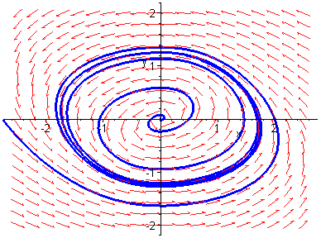
Unstable Focus + Stable Limit Cycle

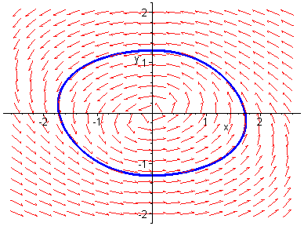
Limit Cycle
APPENDIX 1

CASE STUDIES
Economic Investment

A simplified economic model of a national economy with investment is represented by the dynamical system

where y is the national product and is the investment function.

(a) Show that the system has a single equilibrium point at the origin.

(b) By using the trace-determinant diagram or otherwise show that the equilibrium point cannot be a saddle point. Show further that the equilibrium point is a repeller if

(c) Show that all the conditions of the Hopf bifurcation theorem are satisfied except the asymptotic stability of the origin at the critical value of r.

(d) Show using a Lyapunov function of the form , where m and n are to be determined, that the origin is asymptotically stable at the critical value of r.

(e) Demonstrate computationally the existence of a supercritical Hopf bifurcation at .

Hopf Bifurcation in a Chemical Reaction

A chemical reaction is governed by the system of differential equations

where x and y are concentrations of the reactants and a and b are positive parameters.

(a) Show that the system has a single equilibrium point at

(b) By using the trace-determinant diagram or otherwise show that the equilibrium point cannot be a saddle point. Show further that the equilibrium point is a repeller if

(c) By considering the nullclines

show that the rectangle bounded by the lines , , , is a trapping region for the trajectories of the system.

(d) Deduce using the results of (b) and (c) together with the Poincaré-Bendixson theorem that the system has a stable limit cycle within the rectangle defined in (c).

- Show by computation that the system undergoes a Hopf bifurcation at and state whether it is sub- or super-critical.

APPENDIX 2

ANSWERS AND HINTS

FOR THE EXERCISES

Introduction

Exercises 1

- (a) , stable.
- , stable; , unstable.
- , unstable; , stable.
- , unstable; , stable; , unstable
- Use .
- Write as a first order system, transform to polars, and show that is a solution.

Trapping Regions

Exercises 2

1. (a)
2. (a) Any annular region for which with .
- .
- .

Poincaré-Bendixson Theory

Exercises 3

- Show that in each case the only equilibrium point is at the origin.
- .
- Show that . Choose level curves such that for , and for , .
- . Use the same idea as in Worked Example 2.

Liénard Systems

Exercises 4

- Use Liénard’s theorem.
- (a) Use Liénard’s theorem;
- Globally asymptotically stable for and hence cannot have a limit cycle.

Dulac’s Criterion

Exercises 5

- Use weighting function .
- Use weighting function .

The Hopf Bifurcation

Exercises 6

- Subcritical.
- Use Hopf bifurcation theorem and to confirm asymptotic stability.
- Choose ; subcritical.
- ; .
APPENDIX 3

MAPLE WORK SHEETS

Worked Example 2

> restart:

> with(linalg):

> with(DEtools):

Plot of the nullclines

> yf:=x/(a+x^2);

> yg:=b/(a+x^2);

Need to choose values for a and b

> a:=0.08:b:=0.6:

> plot({yf,yg},x=0..3);

Stability Analysis

Define the dynamical system

> a:='a':b:='b':

> f:=-x+a*y+x^2*y;

> g:=b-a*y-x^2*y;

Obtain the equilibrium point

> ep:=solve({f,g},{x,y});

Find the Jacobian matrix

> u:=[f,g];

> J:=jacobian(u,[x,y]);

> J1:=map(simplify,subs(ep,evalm(J)));

Find the trace and determinant

> trJ1:=trace(J1);

> detJ1:=det(J1);

Now plot the phase portrait

> f1:=-x(t)+a*y(t)+x(t)^2*y(t);

> g1:=b-a*y(t)-x(t)^2*y(t);

> a:=0.08:b:=0.6:

> de1:=diff(x(t),t)=f1;

> de2:=diff(y(t),t)=g1;

> ics:=[[0,1,1],[0,0.3,0.3]];

> DEplot([de1,de2],[x(t),y(t)],t=-10..30,ics,x=0..2,y=0..3,stepsize=0.1,linecolour=blue);

Plot the limit cycle

> DEplot([de1,de2],[x(t),y(t)],t=20..50,ics,x=0..2,y=0..3,stepsize=0.1,linecolour=blue);

Worked Example 3

> restart:
> with(plots):

Define V

> V:=(1-4*x^2-y^2)^2;

Define the system

> f:=x*(1-4*x^2-y^2)-y*(1+x)/2;
> g:=y*(1-4*x^2-y^2)+2*x*(1+x);

Find dV/dt

> dV:=factor(diff(V,x)*f+diff(V,y)*g);

Show contour plots

> contourplot3d(V,x=-0.6..0.6,y=-1.2..1.2,contours=50);
> p1:=contourplot(V,x=-0.8..0.8,y=-1.5..1.5,contours=20):
> p2:=implicitplot(1-4*x^2-y^2,x=-0.8..0.8,y=-1.5..1.5,colour=blue):
> display({p1,p2});

Worked Example 4

> restart:
> with(DEtools):

Define the system

> f:=y(t);
> g:=-x(t)+epsilon*(1-x(t)^2)*y(t);

Set the value of epsilon;

> epsilon:=5:

Obtain the phase portrait

> de1:=diff(x(t),t)=f;
> de2:=diff(y(t),t)=g;
> ics:=[[0,0,0.5]]:
> DEplot([de1,de2],[x(t),y(t)],t=0..30,ics,x=-2..2,y=-8..8,stepsize=0.01,linecolour=blue,maxfun=-1);

and the time series plots for x and y

> DEplot([de1,de2],[x(t),y(t)],t=0..50,ics,linecolour=blue,scene=[t,x],
stepsize=0.01,method=classical[rk4]);
> DEplot([de1,de2],[x(t),y(t)],t=0..50,ics,linecolour=blue,scene=[t,y],
stepsize=0.01,method=classical[rk4]);

Worked Example 6

> restart:
> with(DEtools):

Define the system

> f:=mu*x(t)-y(t)-(x(t)+2/3*y(t))*(x(t)^2+y(t)^2);
> g:=x(t)+mu*y(t)+(3/2*x(t)-y(t))*(x(t)^2+y(t)^2);

Set the value of mu;

> mu:=-4:

Obtain the phase portrait

> de1:=diff(x(t),t)=f;
> de2:=diff(y(t),t)=g;
> ics:=[[0,1,1],[0,-1,1],[0,1,-1],[0,-1,-1]]:
> DEplot([de1,de2],[x(t),y(t)],t=-5..5,ics,x=-3..3,y=-3..3,stepsize=0.01,
method=classical[rk4],linecolour=blue);
Choose another value for mu;

> mu:=4:

Obtain the phase portrait

> de1:=diff(x(t),t)=f;
> de2:=diff(y(t),t)=g;
> ics:=[[0,1,1],[0,-1,1],[0,1,-1],[0,-1,-1]]:
> DEplot([de1,de2],[x(t),y(t)],t=-5..5,ics,x=-3..3,y=-3..3,stepsize=0.01,
method=classical[rk4],linecolour=blue);

Worked Example 7

> restart:
> with(DEtools):

Define the system

> f:=mu*x(t)-y(t)+x(t)*y(t)^2;
> g:=x(t)+mu*y(t)+y(t)^3;

Choose a positive value for mu;

> mu:=0.2:

Plot the phase portrait

> de1:=diff(x(t),t)=f;
> de2:=diff(y(t),t)=g;
> ics:=[[0,1,1],[0,-1,1],[0,1,-1],[0,-1,-1]]:
> DEplot([de1,de2],[x(t),y(t)],t=-5..5,ics,x=-2..2,y=-1.5..1.5,stepsize=0.1,
method=classical[rk4],linecolour=blue);

Choose a negative value for mu;

> mu:=-0.2:

Obtain the phase portrait

> de1:=diff(x(t),t)=f;
> de2:=diff(y(t),t)=g;
> ics:=[[0,1,1],[0,-1,-1],[0,0.2,0.2],[0,-0.2,-0.2]]:
> DEplot([de1,de2],[x(t),y(t)],t=-10..10,ics,x=-2..2,y=-1.5..1.5,
stepsize=0.1,method=classical[rk4],linecolour=blue);
Case Study - Economic Investment

> restart:
> with(linalg):
> with(DEtools):

Define the investment function

> v:=x->arctan(x):

Define the system

> f:=r*v(x)-2*(x+y);
> g:=x;

Find the equilibrium points

> ep:=solve({f,g},{x,y});

Find the Jacobian matrix

> u:=[f,g];
> J:=jacobian(u,[x,y]);
> J0:=subs(ep,evalm(J));

Find the trace and determinant and discriminant

> trJ0:=trace(J0);
> detJ0:=det(J0);
> discJ0:=simplify(trJ0^2-4*detJ0);
> solve(discJ0>0,r);

From these results we have an attractor if r < 2; and a repeller if 2 < r; which is a focus if r < 2+2*sqrt(2); and a node otherwise.

Find the eigenvalues of the Jacobian matrix

> evs:=eigenvals(J0);
> ev1:=evs[1];
> ev2:=evs[2];
> subs(r=2,ev1);
> subs(r=2,ev2);

Thus eigenvalues are purely imaginary at r = 2;.

Also derivative of real part =1/2>0.

To investigate A.S. of the origin at r = 2; use the Lyapunov function

> V:=m*x^2+n*y^2;

Find dV/dt

> dV:=collect(diff(V,x)*f+diff(V,y)*g,[x,y],distributed);

Choose m = 1; and n = 2; to eliminate cross term and let r = 2;.

> dV1:=subs(m=1,n=2,r=2,dV);

This expression is negative except on the line x = 0; which is not a trajectory.

> plot(dV1,x=-2..2);

Thus all the conditions of the Hopf bifurcation theorem are satisfied.

Now obtain the phase portrait to show the bifurcation

> f:=r*v(x(t))-2*(x(t)+y(t)):
> g:=x(t):
> r:=3:
> de1:=diff(x(t),t)=f:de2:=diff(y(t),t)=g:
> ics:=[[0,2,0],[0,0.5,0]]:
> DEplot([de1,de2],[x(t),y(t)],t=-10..10,ics,x=-2.5..2.5,y=-2..2,
stepsize=0.1,linecolour=blue);

> DEplot([de1,de2],[x(t),y(t)],t=20..30,ics,x=-2.5..2.5,y=-2..2,
stepsize=0.1,linecolour=blue);

