- LINEAR SYSTEMS

  - INTRODUCTION
This course is about how to predict the future from a knowledge of how things are at the present time together with a set of rules governing the changes that will occur. These changes are often modelled by differential equations.

Some common examples of differential equation models are

- a simple harmonic oscillator modelled by a second order differential equation. If x is the distance from the rest point at any time then for damped motion the equation is
where and
- and for undamped motion the equation is
- A sky diver falling under gravity and encountering a resistance proportional to his velocity v can be modelled by the first order differential equation
- A predator prey interaction with species x and y e.g. foxes and rabbits can be modelled by the pair of equations

Once the differential equations have been determined the goal is then to use them to predict future behaviour. There are three main approaches for making these predictions

- Analytical techniques
- Numerical techniques
- Qualitative techniques.

In this course you are going to study mainly qualitative methods although some use will be made of both analytical and numerical methods. Qualitative methods involve using geometry to give an overview of the behaviour of the model. You cannot use this method to give precise values of the solution at specific times but it is a powerful method for visualising the characteristics of solutions for general initial conditions and parameters.

A first mental picture of what the solutions look like can be obtained from the direction field. This is a plot of the gradient at specific points. An example of a direction field diagram is shown below. The arrows point in the direction of increasing t.
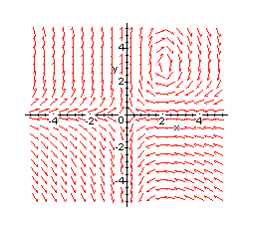

The next step is to sketch a number of trajectories in the x-y plane. Trajectories are
curves passing through given initial points which represent the paths traced by corresponding values of x and y as t changes. The arrows represent the direction of increasing t. The set of curves corresponding to all possible initial conditions gives the phase plane or phase portrait for the system. The aim is to sketch enough of the solutions so that the general qualitative behaviour of all solutions can be surmised by looking at the picture. A number of initial points are chosen scattered over the x-y plane and the solution curve through each of the initial points is sketched. Exactly which initial points and how many are needed to make a good phase plane diagram requires trial and error and some artistic feeling. Equilibrium solutions are special and their trajectories are represented by points. At these points the values of x and y remain constant for all t. Here is an example of a phase portrait.
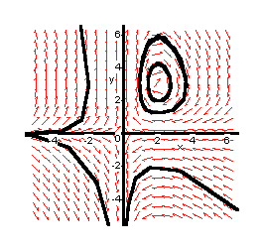

The final step is to interpret the phase portrait. The material on the web will help you with this section.
Look at the point A and trace the trajectory through A following the direction of the arrows. The trajectory is a closed curve and you will eventually return to A. The trajectory repeats the same closed curve over and over and will oscillate with constant amplitude about the rest position forever. This sort of trajectory represents cyclic motion.

Now trace the trajectory through the point B. In this case the trajectory starts with large negative x and small positive y. At first x and y both increase until x reaches a maximum value. Then x decreases while y continues to increase until as x becomes large and negative and y becomes large and positive.
This implies that the starting point is crucial as the solution curves can exhibit different behaviour for different initial conditions.

Next look at the trajectories starting at C and D. You should find that these are straight line trajectories. In this case C moves towards the origin whereas D moves away from it. A straight line trajectory is called a directrix and is an asymptote for the system.
Look at the remaining trajectories and try to describe what happens as . Look carefully at the direction of the arrows. Fill your answers in the space below.

Look closely at the points . What do you think would happen to a point which starts at or ? Would it move away from the initial point or would it stay there for all time? Such points are called equilibrium points.

Look again at the region close to the point . Look carefully at the direction of the arrows in the region of . Do they point towards or away from it? Imagine a point slightly displaced from . Would it return to or move further away from it? Is the point stable or unstable?

Now look at the direction of the arrows in the region of the point . The arrows are neither pointing towards nor away from the point but are forming closed curves around the point. Such a point is said to be neutrally stable.

The phase plane is just one way of visualising the solutions of differential equations. Not all the information about a particular solution can be seen by a glance at the phase portrait. We do not see the time variable, so we do not see how fast the solution traverses the curve. This can be seen by giving the x-t and y-t graphs along with the

The phase portrait. These are commonly referred to as time series plots. Two of these plots are shown below.
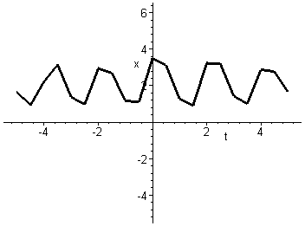

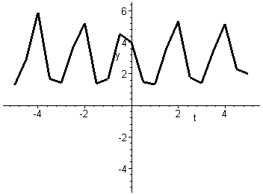

These two graphs show x and y against t for the trajectory passing through the point . They confirm oscillatory motion for this trajectory with period approximately equal to two seconds.

This investigation suggests that equilibrium points, asymptotes and stability are three important features in the interpretation of a phase diagram. In this unit you will learn
- To find equilibrium points
- To find asymptotes
- To investigate the stability of the equilibrium points.
- To plot field diagrams
- To plot phase portraits

