PHASE PORTRAITS
In this section you will learn to

- Plot direction fields
- Plot phase planes
- Plot time series

    - Systems of differential equations
This course is about predicting the long term behaviour of systems which can be modelled by differential equations. There are many different types of differential equations but in this section we will only study autonomous systems of first order equations.

A pair of autonomous first order differential equations have the general form

If the system is linear then the functions are linear and the system is of the form

Any second order differential equation of the form

can be reduced to a pair of linear first order equations by the substitution

The second order equation reduces to

Worked example 1

Reduce the second order differential equation
to a pair of first order equations.
Using the substitution
then
substituting in the equation gives
Therefore

Examples 1
Reduce the following second order differential equations to a pair of first order equations.

    - Direction Field diagram

Consider the harmonic oscillator with damping given by the equations
A first mental picture of what the solutions look like can be obtained from the direction field. This is a plot of the gradient at specific points. The gradient at a point can be obtained from the equation
A table of results is shown below
3 | -1 | -1.3 | -1.7 | -2 | -2.3 | -2.7 | -3
2 | -0.5 | -1 | -1.5 | -2 | -2.5 | -3 | -3.5
1 | 1 | 0 | -1 | -2 | -3 | -4 | -5
0
-1 | -5 | -4 | -3 | -2 | -1 | 0 | 1
-2 | -3.5 | -3 | -2.5 | -2 | -1.5 | -1 | -1.5
-3 | -3 | -2.7 | -2.3 | -2 | -1.7 | -1.3 | -1
 | -3 | -2 | -1 | 0 | 1 | 2 | 3

A plot of the gradient field is shown below

To work out the table for this graph was obviously time consuming even with the small number of points taken. A more illuminating graph can be produced using the algebraic package Maple. You will find the worksheet for this on the web.

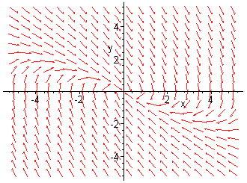

    - Drawing the phase portrait

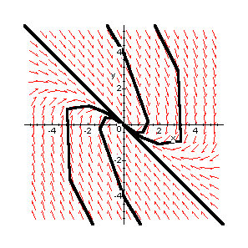
The next step is to turn this field diagram into a phase plane diagram by drawing trajectories through a selection of initial points scattered over the x-y plane. It is advisable to use a computer to sketch thetrajectories. The work sheet for this is on the web. The diagram is reproduced below.

    - Interpreting the phase portrait
Suppose you start at the point A. As t increases x increases and y decreases until x reaches a positive maximum at. Then x and y both decrease until y reaches a
negative minimum. Finally x decreases and y increases as the trajectory approaches.
This behaviour can be confirmed by looking at the plots of x and y against t. These are reproduced below for trajectories through the point (0,4).
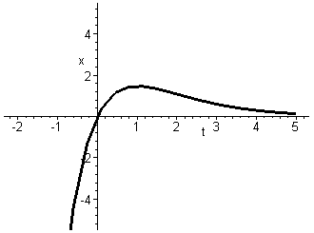

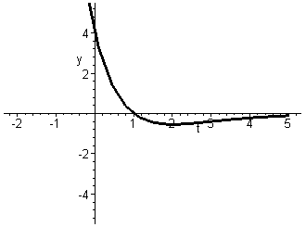

Can you describe what happens if you start at the point B?

Can you find the equilibrium point?

Which way are the arrows pointing? Do you think the point is stable or unstable?

Can you find the asymptote? In this diagram there is only one.

Here are some examples for you to try.

Examples 2
Below are some linear dynamical systems with, in some cases, suggested initial conditions so that you can draw the directrices. You will need to add more points yourself to obtain a clear phase diagram.

For each system
- Plot the direction field diagram
- Add some solution curves to form a phase plane diagram.
- Find the equilibrium point. Are the arrows pointing towards or away from the equilibrium point? Is the equilibrium point stable or unstable?
- How many asymptotes are there?
- Choose one initial point and plot the curves of x and y against t for this point.
- Describe the behaviour of the trajectory through this point as .

YOUR OWN NOTES
Here are some questions to help you summarise this section.
How can a second order differential equation be transformed to a pair of first order linear differential equations?

What is a direction field diagram?

What is a phase plane diagram?

What are time series plots.?

