1.3 STABILITY OF EQUILIBRIUM POINTS

In this section you will learn that the phase plane diagram of a system of equations can be deduced from the eigenvalues of the associated matrix. You will learn

- That a simple system is unstable if one of the eigenvalues are real and positive or the eigenvalues are imaginary and have positive real part, otherwise the equilibrium point is stable.
- To classify the various types of equilibrium points
- To classify the equilibrium points using only the trace, determinant and discriminant of the matrix.

    - Systems with matrices having real eigenvalues

Investigation 1
Two real eigenvalues of the same sign.
The material is on the web. You are going to draw the phase portrait for systems with two positive and two negative eigenvalues. Look carefully at the direction in which the trajectories are moving and determine whether the system is stable or unstable. How many directrices does the system have? Which way are the arrows pointing?

You will find that when the eigenvalues are both positive the phase diagram is as
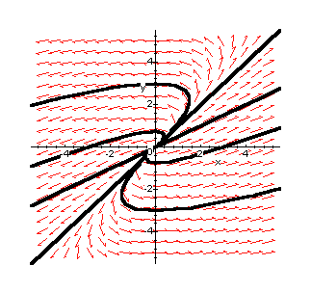
shown below and the equilibrium point is an unstable node. Note that all the arrows point away from the equilibrium point so that all the trajectories are moving away from the equilibrium point. There are two directrices and the arrows on these also point away from the equilibrium point.
When both eigenvalues are negative the phase portrait has a similar structure except that the arrows point towards the equilibrium point showing that all trajectories are moving towards the equilibrium point. The equililibrium point is then a stable node.

Investigation 2
Two real eigenvalues of opposite sign
The material is on the web. You are going to draw the phase portrait for a system with two real eigenvalues of opposite signs. Look carefully at the direction of the arrows and determine whether the system is stable or unstable. How many directrices does the system have? Which way are the arrows pointing?

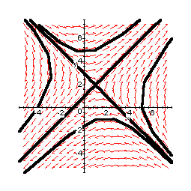
This equilibrium point is an unstable saddle and the phase portrait is produced below.

Note that in this particular example the equilibrium point is at (1,2), that the arrows on one directrice are pointing towards the equilibrium point while the arrows on the other are pointing away from it.

Investigation 3
Two coincident real eigenvalues
The material is on the web. You are going to plot phase portraits of systems with matrices having two coincident eigenvalues. You will consider both diagonal and non diagonal matrices.

Look carefully at the direction of the arrows and determine whether the systems are stable or unstable. How many directrices do the systems have? Which way are the arrows pointing?

When the system is represented by a diagonal matrix you will find that when the eigenvalue is positive the arrows point away from the equilibrium point. It is called
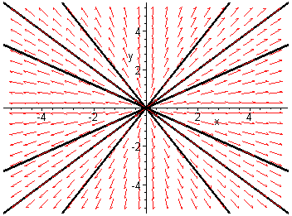
an unstable star node and is reproduced below.

If the eigenvalue is negative the trajectories all move towards the equilibrium point and it is called a stable star node

When the system is represented by a non diagonal matrix if the eigenvalue is positive you will find that the trajectories all move away from the equilibrium point. You will find there is only one directrix. The equilibrium point is called an unstable improper node. In this example the equilibrium point is at (-2,3). The phase diagram is reproduced below.

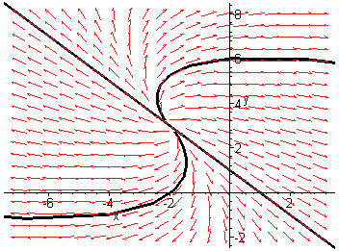

If the eigenvalue is negative the trajectories will all move towards the equilibrium point which will be a stable improper node.

    - Complex eigenvalues.

Investigation 4
The material is on the web. You are going to draw the phase portraits for systems with complex eigenvalues with real parts positive or negative. Look carefully at the direction of the arrows and determine whether the system is stable or unstable. How many directrices does the system have?

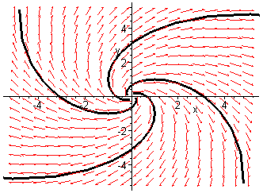
You will notice that the trajectories spiral outwards from the equilibrium point. In general the trajectories will spiral outwards if the real part of the eigenvalue is positive. The equilibrium point is an unstable spiral or focus and is shown below
If the real part is negative the trajectories will spiral towards the equlibrium point and it is called a stable spiral or focus. In both cases there are no directrices.

1.3.3 Imaginary eigenvalues

Investigation 5
The eigenvalues will be purely imaginary if the real part is zero.
The material is on the web. You are going to draw the phase portrait for such a system. Look carefully at the direction of the arrows and determine whether the system is stable or unstable. How many directrices does the system have?

The trajectories are concentric circles surrounding the equilibrium point. Such closed trajectories are characteristic of periodic solutions. No matter at which initial point the trajectory starts it will eventually return to the same point. The equilibrium is a
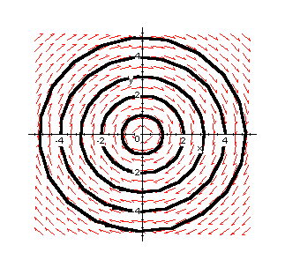
neutrally stable centre and is shown below. There are no directrices.

    - Trace-Determinant diagram.
Since the nature of the equilibrium point depends on the eigenvalues which in turn depend on

it follows that the nature of the equilibrium point can be determined from these three values.
The tr-det diagram divides the plane into regions corresponding to different types of equilibrium point. The diagram is shown below.

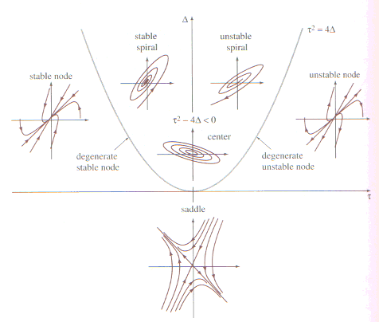

1.3.5 Properties of the trace -determinant diagram
- The discriminant is represented by the quadratic curve which separates the real from the complex cases. Complex eigenvalues are represented by the area above the curve while real eigenvalues are represented by the area below the curve.
- Points on the curve represent degenerate nodes which cover both star nodes (diagonal matrix only) and improper nodes.
- Above the curve spirals or centres occur since the discriminant is negative. Centres will occur on the vertical axis where the trace is zero.
- Above the trace axis and below the curve nodes occur since the determinant and the discriminant are both positive. The eigenvalues must therefore be real and of the same sign.
- The second quadrant where is the only region where stability can occur as this corresponds to eigenvalues which are real and negative or have negative or zero real part.
- Below the trace axis the eigenvalues are real and have opposite sign so this corresponds to saddle points.
- The line det(A)=0 corresponds to a nonsimple system and at this stage nothing can be deduced about such an equilibrium point. Further analysis would be necessary.

- Worked example 1

Given the dynamical system

Find the equilibrium point

Find the matrix A associated with the system
- Find
- Use the trace-det diagram to classify the equilibrium point.
- Plot a phase portrait for the system.
- Plot a pair of time series for the system.

- At the equilibrium point
Therefore
The equilibrium point is (1,-2)
- From the tr-det diagram the equilibrium point is an unstable saddle
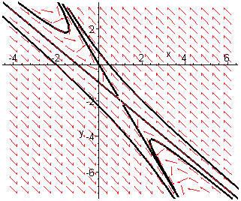
- To plot a phase portrait of the system you will need to use Maple. You will find the work sheet for this diagram on the web. Here is a copy of the phase diagram

- The time series plots are produced below for the point (-3,2)
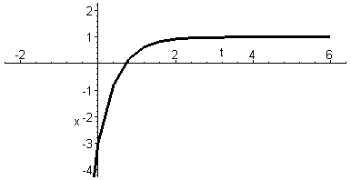

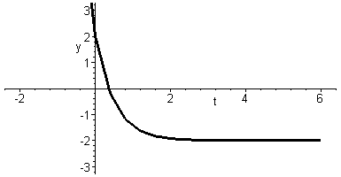
Examples 1
- Using the tr-det diagram classify the equilibria
Tr(A) | Det(A) |  | Type of equililibrium point
4 | 2 | 3
-4 | 2 | -3
4 | -2
3 | 4 | 0
3 | 2 | -2
0 | 3
5 | 0 | 3

- Find and classify the equilibrium points of the following dynamical systems. Obtain phase portraits and show typical time series plots.

Your own notes

Here are some questions to help you summarise this section.
How do you know if a matrix A has real or complex eigenvalues?

How do you know if a phase portrait has two directrices, one directrix, an infinite number of directrices or no directrices?

What must be true about the eigenvalues of the matrix A if the equilibrium point is stable?

What must be true about tr(A) if the equilibrium point is stable?

What must be true about the eigenvalues of the matrix A if the equilibrium point is unstable?

What must be true about tr(A) if the equilibrium point is unstable.

What must be true about the equilibrium point if det(A)<0

