2. NONLINEAR SYSTEMS

- Introduction.

In an autonomous nonlinear system the differential equations contain nonlinear terms such as These dynamical systems have many applications including the simple pendulum model given by

the predator prey model given by

the competing species model given by

When a plane autonomous system is linear of the form

with determinant A0, there is only one equilibrium point which is at and a precise geometrical description of solutions is possible, both near the equilibrium point and globally once the eigen values and eigenvectors of A have been found.
However, a nonlinear autonomous system may have many equilibrium points. Given an initial point we do not know which equilibrium point (if any) the solution curve will approach. We cannot even be sure that a solution curve through a point initially close to an equilibrium point will remain close to that equilibrium point. It may well be driven to a second equilibrium point .

Investigation 1
Consider the competition model

and its phase plane diagram showing several solution curves.
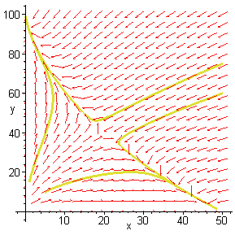

The equilibrium points are and By using the material on the internet examine the phase diagram of the region close to each equilibrium point.

Can you decide which equilibrium points are stable and which are unstable?
.
How can we use this knowledge to help us understand the long term behaviour of the model?

Look at the curve labelled A. Starting with small values of x and y, initially, as the curve moves away from the unstable equilibrium towards the equilibrium the values of x and y increase until y reaches a maximum value. The curve now comes under the influence of the unstable equilibrium point and is repelled by it and driven towards the stable equilibrium point . Thus, x continues to increase whilst y decreases so that as but y dies out.

The biological interpretation is that the two populations are competing for a limited resource which initially is sufficient for both populations to increase. Eventually there is not enough resource to sustain both populations so y begins to decrease and becomes extinct leaving all the resources for x which then increases until its carrying capacity of 50 is reached.

Now look at the curves labelled B, C, and D and see if you can describe what is happening on each of these curves and interpret the trends.

In this model the initial conditions are crucial. Can you see why the starting point is so important?

This example suggests that a natural first step towards understanding a nonlinear system would be to classify the equilibrium points. In this unit you will learn

- how a nonlinear system can be approximated to a linear system near an equilibrium point by a process called linearisation.
- that under certain conditions solutions of the nonlinear system close to an equilibrium point have the same geometric features as the solutions of its linearisation.
- that there are certain cases when no conclusions can be drawn and further analysis is necessary.

